Bank materiałów z sugestiami źródeł do utrwalenia wiedzy

Fill in the gaps with you or your.
What’s ______ name?
What’s ______ surname?
Where do ______ live?
What’s ______ telephone number?
How old are ______?
What do ______ do?
Where ______ you from?
What are ______ interested in?
Match the questions with the answers.
- What’s your name?  - What’s your surname?  - Where do you live?  - What’s your telephone number?  - How old are you?  - What do you do?  - Where are you from?  - What are you interested in? | - I am interested in tennis.  - I am from England.  - I am an IT specialist.  - I am seventy years old.  - My telephone number is 555 897 241  - I live in London.  - My surname is Keths.  - My name is Sue.

Answer the questions.

- What’s your name?
____________________________________________________________________________________

- What’s your surname?
____________________________________________________________________________________

- Where do you live?
____________________________________________________________________________________

- What’s your telephone number?
____________________________________________________________________________________

- How old are you?
____________________________________________________________________________________

- What do you do?
____________________________________________________________________________________

- Where are you from?
____________________________________________________________________________________

- What are you interested in?
____________________________________________________________________________________

Ask the questions to your partners. Write down their answers to the questions.

Question | Partner 1 | Partner 2
What’s your name?
What’s your surname?
Where do you live?
What’s your telephone number?
How old are you?
What do you do?
Where are you from?
What are you interested in?

Utrwalenie przy użyciu technologii:
English Greetings and Introductions - Spoken English
https://www.youtube.com/watch?v=sp3xU5WvRjA
SELF INTRODUCTION | How to Introduce Yourself in English | Tell Me About Yourself Interview Answer https://www.youtube.com/watch?v=QgjkjsqAzvo

Ask and answer the following questions in English:
Ile masz lat? - ______________________________________________
Mam 60 lat. - ______________________________________________
Jaki jest Twój numer telefonu? - ___________________________________________
Mój numer telefonu to: +48556978684? -_______________________________________________
Match the numbers.
1  2  3  4  5  6  7  8  9  10 | - ten  - three  - seven  - one  - four  - two  - five  - eight  - six  - nine | 20  30  40  50  60  70  80  90  100 | - thirty  - seventy  - forty  - twenty  - fifty  - eighty  - sixty  - a hundred  - ninety

Utrwalenie przy użyciu technologii:
English pronunciation; Numbers https://www.youtube.com/watch?v=iNU1ILy63Wc
How to Say Numbers in English | American English Pronunciation https://www.youtube.com/watch?v=oXIz_2nad7s
Telephone number listening practice in English https://www.youtube.com/watch?v=RUX9YlEbenI

Family members. Translate the words:

parents –
mother –
father –

grandparents -
grandmother –
grandfather –

child –
children –
son –
daughter –
sister –
brother -

grandchild –
grandchildren -
grandson –
granddaughter-

cousin –

Describe your family:

I have got ____________________________________________________________________________________________________________________________________________________________________________________________________________________________________________________________________________________________________________________________________________________________________________________________________________________

Describe three members of your family:

This is my ______________________________.
Her name is _________________________________________.
Her surname is _________________________________________.
She is ________________________________ years old.
She lives in _____________________________.

This is my _______________________________.
His name is _________________________________.
His surname is _________________________________________.
He is __________________________________ years old.
He lives in _______________________________.
____________________________________________________________________________________________________________________________________________________________________________________________________________________________________________________________________________________________________________________________________________________________________________________________________________________
Utrwalenie przy użyciu technologii:
Family Tree Chart: Useful Family Relationship Chart with Family Words in English https://www.youtube.com/watch?v=zNLRiB-qOAs
Talking About Your Family in English - Spoken English Lesson https://www.youtube.com/watch?v=vXI2lRCnTKw
English Conversation Learn English Speaking English Subtitles Lesson 01
https://www.youtube.com/watch?v=NdXPnJLR07E

Label the pictures.

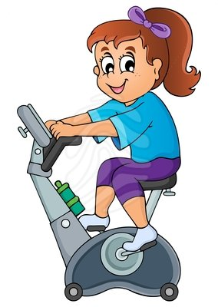
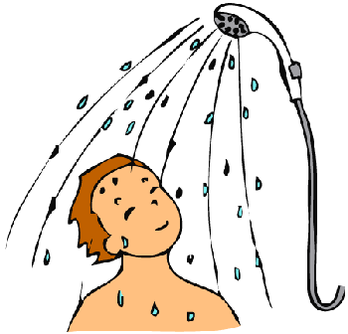
Źródło: grafika google

Which of the activities presented do you do every day?
Say:
I _________________________________ every day.

What do you do first?
Say: I _______________ first. Then, I_________________. Next, I _______________________.
I usually _____________________________________ first.
I live in Lublin.
He lives in Lublin.

I do homework every day.
She does homework every day.

I usually drink coffee in the morning.
My sister usually drinks coffee in the morning.

(Ja) gotuję obiad codziennie. __________________________________________________________________
Mój mąż gotuje obiad codziennie. ____________________________________________________________

(Ja) wstaję bardzo wcześnie. ___________________________________________________________________
Moja żona wstaje bardzo wcześnie. ____________________________________________________________

Utrwalenie przy użyciu technologii:
Daily Routines in English – Vocabulary https://www.youtube.com/watch?v=zNDIhOXy3IU
Daily Activities | Present Tense | ESL Classics - songs for learning English
https://www.youtube.com/watch?v=k0FHGnc6iHg
Daily Routines: English Language https://www.youtube.com/watch?v=WxISeXIPh9g&t=10s
Daily Routine in English - Learn How To Talk About Your Daily Routine - Lesson 24
https://www.youtube.com/watch?v=MnIQ2_G8rxM

Say the alphabet

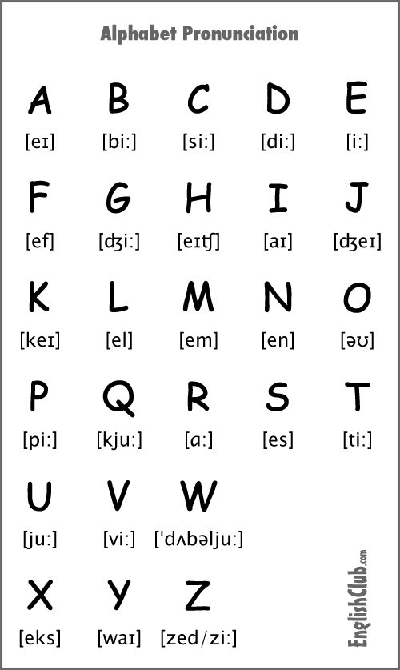
Źródło: EnglishClub.com

How do you spell your name? - ______________________________________________________
Can you spell your name, please? - ____________________________________________________
It’s A-N-D-R-E-W - __________________________________________________________________

Utrwalenie przy użyciu technologii:
Angielski alfabet| Po Cudzemu #3 https://www.youtube.com/watch?v=kXWQgRkXJqE
Piosenka: https://www.youtube.com/watch?v=6kGKYSi35zQ
Gry online: https://www.education.com/games/alphabet/

Excuse me, what’s the time? - __________________________________________________________________
Excuse me, what time is it? - ____________________________________________________________________
Could you tell me the time, please? ____________________________________________________________
It’s …………. - ______________________________________________________________________________________

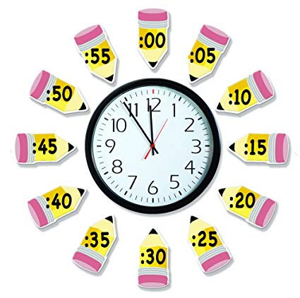
źróło: grafika google
Option 1:
It’s hour + minutes (a.m./p.m.)
It’s eleven fifty-five.

Option 2:
It’s minutes + past/to + hour
(in the morning/in the afternoon/in the evening/at night)
It’s five to twelve.

What’s the time? Write the times.

___________ - It’s quarter to eight.
___________ - It’s three twenty-five.
___________ - It’s half past eleven.
___________ - It’s midnight.
___________ - It’s quarter past six.
___________ - It’s eight fifty.
___________ - It’s ten to nine.
___________ - It’s half past seven.
___________ - It’s twenty past three.
___________ - It’s twenty-five to ten.

7:00 - _______________________________________________________________________________
8:30 - _______________________________________________________________________________
10:15 - _______________________________________________________________________________
4:55 - _______________________________________________________________________________
9:45 - _______________________________________________________________________________
12:05 - _______________________________________________________________________________
11:20 - _______________________________________________________________________________
6:30 - _______________________________________________________________________________
5:56 - _______________________________________________________________________________
3:15 - _______________________________________________________________________________

Utrwalenie przy użyciu technologii:
How to Tell the Time in English - Beginner English Lesson https://www.youtube.com/watch?v=SePm7J_cdgA
Learn to Tell Time #1 | Telling the Time Practice for Children | What's the Time? | Fun Kids English https://www.youtube.com/watch?v=EIxaxnageTo

Match the words in Polish with their equivalents in English:

Polish | English
- galeria sztuki  - zamek  - kino  - muzeum  - teatr  - bank  - apteka  - dom towarowy  - targ  - centrum handlowe  - supermarket  - most  - park  - rzeka  - droga  - plac  - ulica  - stacja autobusowa  - stacja kolejowa  - biuro podróży  - kościół  - szpital  - komisariat policji  - poczta  - szkoła  - centrum sportowe  - ratusz | - a church  - a bridge  - a park  - a river  - a post office  - a bus station  - a railway station  - a travel agent’s  - a road  - a square  - a street  - a police station  - a hospital  - a school  - a sports centre  - a town hall  - a shopping centre  - a supermarket  - a department store  - a market  - a chemist’s  - an art gallery  - a castle  - a museum  - a theatre  - a cinema  - a bank
Answer the following questions in pairs.
- Do you live in a town or in a city?
I live in ______________________________
- What are the top three tourists attractions in your city?
In my city there is/are ______________________________________________________

Translate into English the following questions:

- Przepraszam, gdzie jest ulica Lubartowska? - ______________________________________________________________________________________________
- Przykro mi, nie wiem.
______________________________________________________________________________________________
- Przepraszam, czy ulica Lubartowska jest w pobliżu?
______________________________________________________________________________________________
- Ta ulica jest niedaleko, ale nie wiem dokładnie gdzie.
_____________________________________________________________________________________________
- Przepraszam, czy możesz powiedzieć mi drogę do Bramy Krakowskiej?
_____________________________________________________________________________________________
- Przepraszam, jak mogę dojść do Bramy Krakowskiej?
_____________________________________________________________________________________________
- Przepraszam, czy możesz powiedzieć to jeszcze raz?
_____________________________________________________________________________________________
- Idź prosto tą ulicą i skręć w lewo.
_____________________________________________________________________________________________
- Jedź autobusem numer 10 albo weź taksówkę.
_____________________________________________________________________________________________

Giving directions. Translate into Polish:

on the corner – _______________________________________
at the traffic lights – _______________________________________
a roundabout – _______________________________________
opposite – _______________________________________
turn left – _______________________________________
turn right – _______________________________________
go past – _______________________________________
go along – _______________________________________
go straight on – _______________________________________
go through – _______________________________________

Utrwalenie przy użyciu technologii:
Places in a city - English Educational Videos | Little Smart Planet https://www.youtube.com/watch?v=UdDXlL9u0vI
Places in a City - Learn English Vocabulary
https://www.youtube.com/watch?v=hpX8UkieizY
English for Beginners #30: Places Around the City | Easy English at Home
https://www.youtube.com/watch?v=kGww0ZN_kUg
Asking for and Giving Directions
https://www.youtube.com/watch?v=DPYJQSA-x50
Not Afraid to Ask for Directions | Brain Games
https://www.youtube.com/watch?v=5Ikl_1f-aYQ
English Made Easy: Intro Unit 13 Giving Directions
https://www.youtube.com/watch?v=20TTTzFu8JY

Fill in the dialogue.

Shop assistant: Hello. Can I ______________ you?
Customer: Hello. H______ much is this newspaper?
Shop assistant: Let me see … that’s £3.90.
Customer: OK, can I h______ the newspaper
Shop assistant: Yes, sure.
Customer: And maybe do you h_________ a can of coke?
Shop assistant: Yes. Here you are. Is that ______________?
Customer: I think so. Oh … and these chocolate bars.
Shop assistant: OK.
Customer: How m______ is that?
Shop assistant: That’s £9.40, _____________.
Customer: H_______ you are.
Shop assistant: Thank you … and there’s £11.60 ______________. Would you ________ a green bag?
Customer: No, it’s f___, thanks. Bye.
Shop assistant: ______________ bye.

Translate the following sentences into English:
- Czym mogę służyć? ________________________________________________________________
- Ile kosztuje ta gazeta? ________________________________________________________________
- To kosztuje 7euro. ________________________________________________________________
- Czy mogę prosić tę gazetę? _____________________________________________________________
- Czy macie kanapki? ________________________________________________________________
- Bardzo proszę. ________________________________________________________________
- Czy chciałaby Pani torbę? ________________________________________________________________
- Nie, dziękuję. ________________________________________________________________

Write your own dialogue at the shop.
______________________________________________________________________________________________________________________________________________________________________________________________________________________________________________________________________________________________________________________________________________________________________________________________________________________________________________________________________________________________________________________________________________________________________________________________________________________________
Utrwalenie przy użyciu technologii:
Shopping at the Grocery Store - English Conversation
https://www.youtube.com/watch?v=GlNbzAGZC2M
Shopping: Grocery Shopping
https://www.youtube.com/watch?v=1QCwbh9Yk0M

