http://www.answers.com/Q/What_is_historical_tourism?#slide=1

Heritage Tourism • Introduction http://museum.msu.edu/?q=node/705
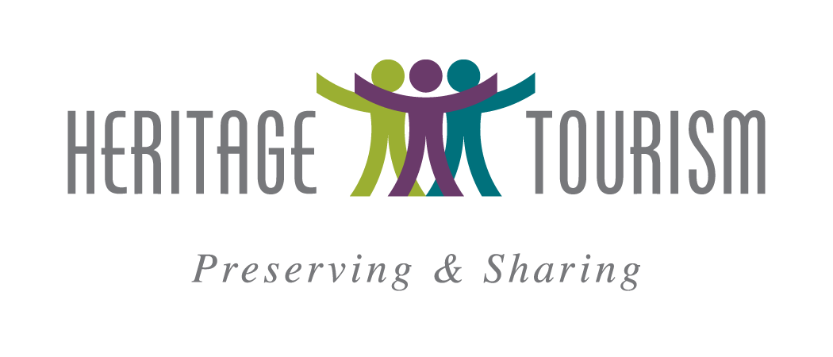

Introduction • What is heritage tourism?
Heritage tourism encompasses elements of living culture, history, and natural history of place
that communities value and steward for the future. These elements are very specific to a community
or region and can contribute to pride, stability, growth, and economic development.
Heritage and culture are especially critical in rural settings.
The Heritage tourism Initiative Core Team

Heritage tourism is a new combination of words to look at tourism planning more comprehensively. It affirms that we have identified significant elements of our places as important enough to preserve and to pass on to future generations. Heritage Tourism also denotes that we are dedicated to caring for these resources and sharing them. Heritage Tourism is an active, engaging, and ongoing process that involves community residents, organizations, civic institutions and governments working together.
•Heritage implies action. It is a responsibility for stewardship and protection–insuring continuation into the future.
•Tourism is also purposeful. It is the commercial organization and operation of places and activities that interest and attract visitors to our communities and regions for their enjoyment and for our economic benefit.
Many tourism efforts focus on cultural OR natural resources. Heritage tourism offers an umbrella covering both. Heritage tourism encompasses elements of living culture, history, natural history of place and the natural environment that communities value and steward for the future. Natural and cultural heritage elements make a community and region unique. They are keys to community character that draw residents and visitors alike.
Heritage is what we value as a people and choose to pass on to future generations. Heritage has shaped the past and present, will influence future development, and can contribute to stability, growth, and economic development.

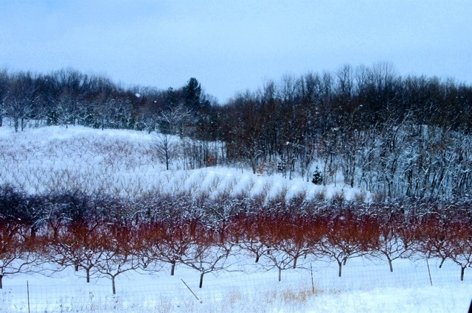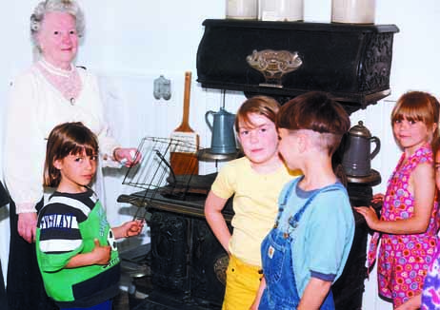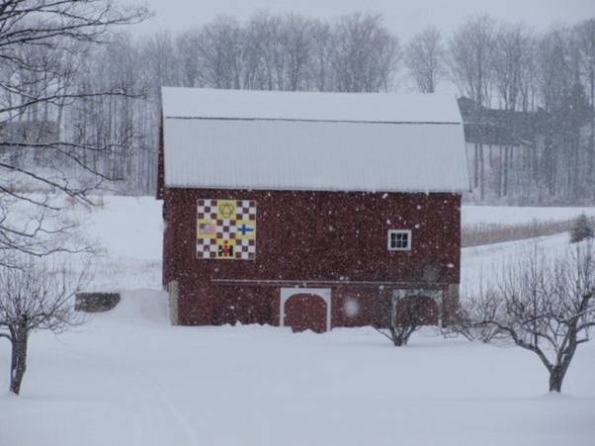

Oceana County (MI) orchards in winter, courtesy G. Foster. Youth learn about Old-time ways at the

Iron County Museum (MI). Old Mission Peninsula (MI) Quilt Barn Trail -- dramatic in winter too!

Find and showcase your sense of place.
“Sense of place” is unique to the people and experience of particular communities or regions and about a universal experience with which everyone can connect. Within the umbrella of heritage tourism, cultural and natural resources of a place are so intertwined they must be considered together. Elements of “place” are many: the natural resources, the built environment (cultural resources), the intersection and influence of people; the past and present and even future hopes. The natural environment influences what follows—types of farming, vocations (lumbering, maritime), what our houses are built of and how people came to live on and from the land. Recreation, business / industry and community grow from these elements and intersections.

Community and Region Wide . . . an incoming tide raises all the boats
Work across your community, with neighboring communities and across the region. You are not in competition with others; together you can create density and a destination to attract visitors to come, to stay, and to return. Tourists are more inclined to stay and return if they find numerous authentic things to do, places to stay and local food to eat.
This project will help organizations and communities become more effective at tourism.
While we will not be developing sites, a result of this work is that others will develop more effective
sites, communities will plan and promote together, customers will be engaged and understood,
and organizations and communities will impact their own sustainability.
–Connie Mefford, University of Missouri

Authenticity and the Real Stories of your Place
The National Trust for Historic Preservation has developed the most respected definition for tourism in use today . . . travel to experience the places, artifacts and activities that authentically represent the stories and people of the past and present. This attention to authenticity extends the capability of tourism products and experiences to every place and people–your place and your people. These real stories bring to life the history, culture and meaning of your place.

A Process Driven Approach
These resources are offered for your use and inspiration. Draw from them and adapt them to fit your needs. Develop a diverse team that represents stakeholders, geography, skills and expertise. This is a process based approach that addresses: assessment/readiness, planning, developing, implementing and evaluating tourism resources and approaches. This work is never done; it must be ongoing.
These Resources will help you to implement a strategy for improving
community health and economic stability as the community itself defines them.
Larry Dickerson, University of Missouri

These processes are also not linear! Each community comes to tourism planning from a different place, with different experiences and goals. Each module can stand alone or can be built upon with materials from the others. Our hope is that these materials guide you to use heritage tourism as an economic and community development strategy.

What follows are materials which focus on critical aspects of tourism development:

• The Basics: Is heritage tourism a fit for your community?
• Getting Started: Assessment and Engaging the Community
• Organizing for Heritage Tourism – cross-community/region and a diverse team
• The Plan – Strategic and Long Term Thinking
• Implementing the Plan: Product Development, Marketing, Hospitality
• Evaluation and Renewal – Cycles Towards Improvement
These modules do not go into great depth, but will provide introductory concepts and suggestions for how it can be accomplished. Don’t work in isolation. Engaging community will build investment and provide a platform for discovery that can help a community see itself through “new” eyes. The resources and links provide tools, guidance and experiences that you can use in your community. We recommend a diverse community team and using an experienced facilitator as needed.

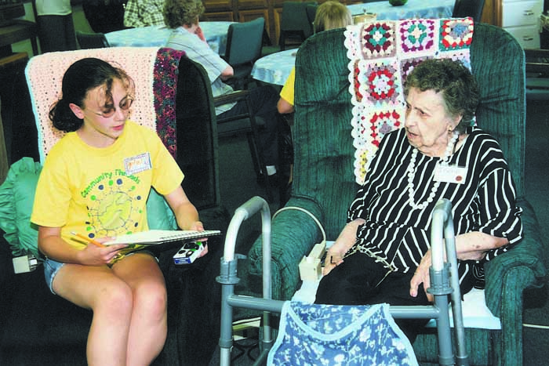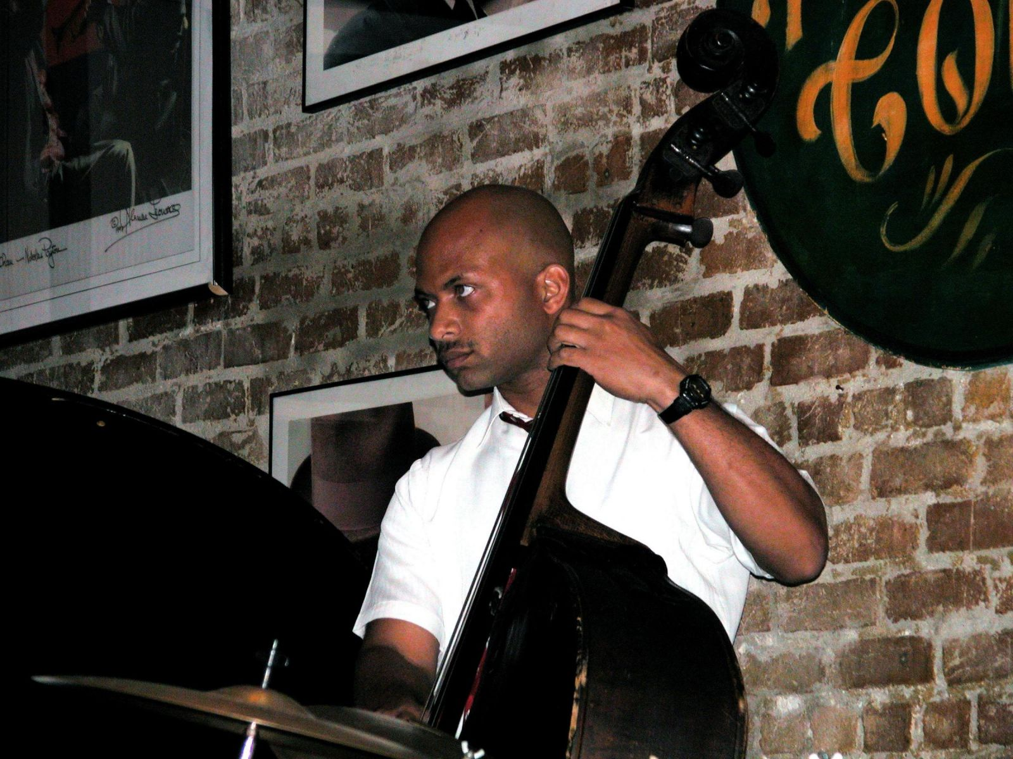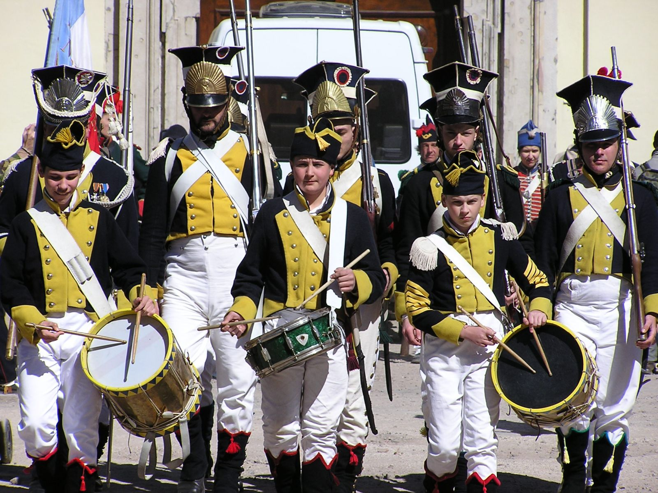

Gaylord rea Council for the Arts summer camp students doing oral history interviews to tell stories of

Otsego County (MI) history. American blues and drumb corp photos from PhotoMorgue.

Importance of Heritage Tourism
Over the past 15+ years, the popularity of heritage tourism has grown with travelers and with those developing new tourism attractions. For example, between 1996 and 2002 heritage travel increased by 13 percent, more than twice the growth of U.S. travel overall (5.6 percent).
Tourism is big business. According to statistics from the U.S Travel Association (USTA), in 2010 travel and tourism directly contributed $759 billion to the U.S. economy. Travel and tourism is one of America’s largest employers, directly employing more than 7.4 million people and creating a payroll income of $188 billion, and $118 billion in tax revenues for federal, state and local governments. In addition to creating new jobs, new businesses, and higher property values, well-managed tourism improves the quality of life and builds pride in the community. That is particularly true for the heritage segment of the market.
A national study completed by Mandala Research in the Fall of 2009, The Cultural and Heritage Traveler, indicated that 78 percent of U.S. adults who traveled for leisure in 2009 (118.3 million travelers) were considered heritage travelers. Heritage travelers stay longer and spend more money than other kinds of travelers, making them a very attractive target tourism market.
The U.S. Travel Association (USTA)’s 2003 Cultural/Historic Traveler study confirmed that cultural heritage travelers take frequent trips, with 25 percent taking three or more trips a year.
Heritage travelers are more likely to take part in a wide variety of activities when they are traveling: 17 percent participate in four or more activities compared with 5 percent of all travelers. Other activities such as visiting state/national parks, participating in culinary activities such as sampling artisan food and wines, visiting farmers’ markets and enjoying unique dining experiences rank highly with this target audience. The Mandala study found that heritage travelers are looking for more than just museums or historic sites. They are interested in “experiences where the destination, its buildings, and surroundings have retained their historical character…as well as lodging that reflects the local culture.” Combining experiences at historic sites with complementary attractions is an effective strategy to use heritage tourism to increase the length of stay and tourism expenditures.

Economic Beneifts
The economic benefits of heritage tourism include creating new jobs and businesses, increasing tax revenues, and diversifying the local economy. These economic benefits are not the only reason why heritage tourism may be good for your community—it has quality-of-life benefits as well. Heritage tourism helps preserve your town’s unique character, which results in greater civic pride. Residents benefit too! There are more opportunities available such as shops, activities, and entertainment offerings that the local market alone might not be able to support.

Regionalism as a concept
Working together pools vital resources. . . . A regional approach can promote dialogue
between communities, connect resources and people, and leverage capacities and assets.
Connie Mefford, University of Missouri Extension

One recent thrust in economic development is to work on a regional basis.
1. Regions with similar geographic characteristics
2. Regions that are unique in culture or heritage
3. Functional regions that share common concerns or assets
4. Economic regions that share an economic base
5. Political regions that are governmental jurisdictions
6. Administrative regions that share basic infrastructure
7. Data regions such as census districts
8. Issue regions that have some basic issue(s) in common
These suggest ways to determine what your regional boundaries are and how you choose to work together within them. It is important to consider all factors when determining the makeup of your region. Communities in your region may also be parts of “other” regions.
In determining what region(s) you are a part of, start with what makes sense and use the things that you have most in common with other communities to work together on a “regional” basis. Work with those communities with which you share the most common goals and interests.
A regional approach can help you pursue common goals and also help expand your assets and capacities to achieve those goals. Working together pools vital resources needed to pursue viable economic strategies for your region. A regional approach can promote dialogue between communities, connect resources and people, and leverage capacities and assets. Regional approaches to economic and community development can help your community sustain its community health in new and exciting ways.

Successful regional efforts include:
• Recognizing the new realities of economic development
• Developing regional ties and connections
• Taking a global view of economic development, while focusing on local opportunities
• Understanding your region's strengths and weaknesses
• Being flexible and adaptable
• Building upon your region’s opportunities, capacities and assets
• Being responsive to new opportunities
• Building in evaluation to learn how to be successful and to see what really works

References
Dickerson, Larry. Creating Healthy Communities, The Process of Community Discovery; University of Alaska Fairbanks Cooperative Extension, 2001.
Dickerson, Adams, Flora, Gulick, Jeanetta, Nakazawa. Building A Strong Community; University of Alaska Fairbanks Cooperative Extension, Forthcoming Fall 2013.
Nebraska State Historical Society Nebraska Heritage Tourism Plan. University of Nebraska Bureau of Business Research abd Heritage Tourism Program, National Trust for Historic Preservation. 2011.

