Tourism, Britannica
https://www.britannica.com/topic/tourism

Tourism
menu
Written by: John K. Walton
- Read
- View All Media (20)
- View History
- Edit
- Feedback
Tourism, 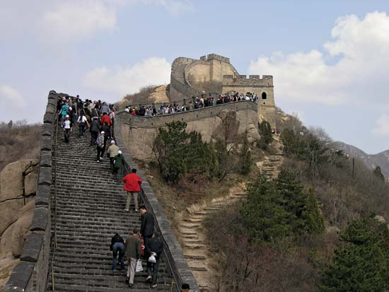the act and process of spending time away from home in pursuit of recreation, relaxation, and pleasure, while making use of the commercial provision of services. As such, tourism is a product of modern social arrangements, beginning in western Europe in the 17th century, although it has antecedents in Classical antiquity. It is distinguished from exploration in that tourists follow a “beaten path,” benefit from established systems of provision, and, as befits pleasure-seekers, are generally insulated from difficulty, danger, and embarrassment. Tourism, however, overlaps with other activities, interests, and processes, including, for example, pilgrimage. This gives rise to shared categories, such as “business tourism,” “sports tourism,” and “medical tourism” (international travel undertaken for the purpose of receiving medical care).

The origins of tourism
By the early 21st century, international tourism had become one of the world’s most important economic activities, and its impact was becoming increasingly apparent from the Arctic to Antarctica. The history of tourism is therefore of great interest and importance. That history begins long before the coinage of the word tourist at the end of the 18th century. In the Western tradition, organized travel with supporting infrastructure, sightseeing, and an emphasis on essential destinations and experiences can be found in ancient Greece and Rome, which can lay claim to the origins of both “heritage tourism” (aimed at the celebration and appreciation of historic sites of recognized cultural importance) and beach resorts. The Seven Wonders of the World became tourist sites for Greeks and Romans.
Pilgrimage offers similar antecedents, bringing Eastern civilizations into play. Its religious goals coexist with defined routes, commercial hospitality, and an admixture of curiosity, adventure, and enjoyment among the motives of the participants. Pilgrimage to the earliest Buddhist sites began more than 2,000 years ago, although it is hard to define a transition from the makeshift privations of small groups of monks to recognizably tourist practices. Pilgrimage to Mecca is of similar antiquity. The tourist status of the hajj is problematic given the number of casualties that—even in the 21st century—continued to be suffered on the journey through the desert. The thermal spa as a tourist destination—regardless of the pilgrimage associations with the site as a holy well or sacred spring—is not necessarily a European invention, despite deriving its English-language label from Spa, an early resort in what is now Belgium. The oldest Japanese onsen (hot springs) were catering to bathers from at least the 6th century. Tourism has been a global phenomenon from its origins.
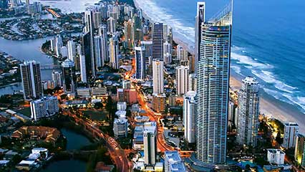play_circle_outlineModern tourism is an increasingly intensive, commercially organized, business-oriented set of activities whose roots can be found in the industrial and postindustrial West. The aristocratic grand tour of cultural sites in France, Germany, and especially Italy—including those associated with Classical Roman tourism—had its roots in the 16th century. It grew rapidly, however, expanding its geographical range to embrace Alpine scenery during the second half of the 18th century, in the intervals between European wars. (If truth is historically the first casualty of war, tourism is the second, although it may subsequently incorporate pilgrimages to graves and battlefield sites and even, by the late 20th century, to concentration camps.) As part of the grand tour’s expansion, its exclusivity was undermined as the expanding commercial, professional, and industrial middle ranks joined the landowning and political classes in aspiring to gain access to this rite of passage for their sons. By the early 19th century, European journeys for health, leisure, and culture became common practice among the middle classes, and paths to the acquisition of cultural capital (that array of knowledge, experience, and polish that was necessary to mix in polite society) were smoothed by guidebooks, primers, the development of art and souvenir markets, and carefully calibrated transport and accommodation systems.

Technology and the democratization of international tourism
Transport innovation was an essential enabler of tourism’s spread and democratization and its ultimate globalization. Beginning in the mid-19th century, the steamship and the railway brought greater comfort and speed and cheaper travel, in part because fewer overnight and intermediate stops were needed. Above all else, these innovations allowed for reliable time-tabling, essential for those who were tied to the discipline of the calendar if not the clock. The gaps in accessibility to these transport systems were steadily closing in the later 19th century, while the empire of steam was becoming global. Railways promoted domestic as well as international tourism, including short visits to the coast, city, and countryside which might last less than a day but fell clearly into the “tourism” category. Rail travel also made grand tour destinations more widely accessible, reinforcing existing tourism flows while contributing to tensions and clashes between classes and cultures among the tourists. By the late 19th century, steam navigation and railways were opening tourist destinations from Lapland to New Zealand, and the latter opened the first dedicated national tourist office in 1901.
After World War II, governments became interested in tourism as an invisible import and as a tool of diplomacy, but prior to this time international travel agencies took the lead in easing the complexities of tourist journeys. The most famous of these agencies was Britain’s Thomas Cook and Son organization, whose operations spread from Europe and the Middle East across the globe in the late 19th century. The role played by other firms (including the British tour organizers Frame’s and Henry Gaze and Sons) has been less visible to 21st-century observers, not least because these agencies did not preserve their records, but they were equally important. Shipping lines also promoted international tourism from the late 19th century onward. From the Norwegian fjords to the Caribbean, the pleasure cruise was already becoming a distinctive tourist experience before World War I, and transatlantic companies competed for middle-class tourism during the 1920s and ’30s. Between the World Wars, affluent Americans journeyed by air and sea to a variety of destinations in the Caribbean and Latin America.
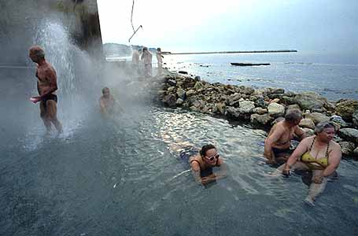Tourism became even bigger business internationally in the latter half of the 20th century as air travel was progressively deregulated and decoupled from “flag carriers” (national airlines). The airborne package tour to sunny coastal destinations became the basis of an enormous annual migration from northern Europe to the Mediterranean before extending to a growing variety of long-haul destinations, including Asian markets in the Pacific, and eventually bringing postcommunist Russians and eastern Europeans to the Mediterranean. Similar traffic flows expanded from the United States to Mexico and the Caribbean. In each case these developments built on older rail-, road-, and sea-travel patterns. The earliest package tours to the Mediterranean were by motor coach (bus) during the 1930s and postwar years. It was not until the late 1970s that Mediterranean sun and sea vacations became popular among working-class families in northern Europe; the label “mass tourism,” which is often applied to this phenomenon, is misleading. Such holidays were experienced in a variety of ways because tourists had choices, and the destination resorts varied widely in history, culture, architecture, and visitor mix. From the 1990s the growth of flexible international travel through the rise of budget airlines, notably easyJet and Ryanair in Europe, opened a new mix of destinations. Some of these were former Soviet-bloc locales such as Prague and Riga, which appealed to weekend and short-break European tourists who constructed their own itineraries in negotiation with local service providers, mediated through the airlines’ special deals. In international tourism, globalization has not been a one-way process; it has entailed negotiation between hosts and guests.

Day-trippers and domestic tourism
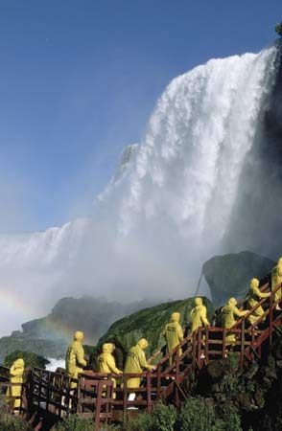While domestic tourism could be seen as less glamorous and dramatic than international traffic flows, it has been more important to more people over a longer period. From the 1920s the rise of Florida as a destination for American tourists has been characterized by “snowbirds” from the northern and Midwestern states traveling a greater distance across the vast expanse of the United States than many European tourists travel internationally. Key phases in the pioneering development of tourism as a commercial phenomenon in Britain were driven by domestic demand and local journeys. European wars in the late 18th and early 19th centuries prompted the “discovery of Britain” and the rise of the Lake District and Scottish Highlands as destinations for both the upper classes and the aspiring classes. The railways helped to open the seaside to working-class day-trippers and holidaymakers, especially in the last quarter of the 19th century. By 1914 Blackpool in Lancashire, the world’s first working-class seaside resort, had around four million visitors per summer. Coney Island in Brooklyn, New York, had more visitors by this time, but most were day-trippers who came from and returned to locations elsewhere in the New York City area by train the same day. Domestic tourism is less visible in statistical terms and tends to be serviced by regional, local, and small family-run enterprises. The World Tourism Organization, which tries to count tourists globally, is more concerned with the international scene, but across the globe, and perhaps especially in Asia, domestic tourism remains much more important in numerical terms than the international version.

A case study: the beach holiday
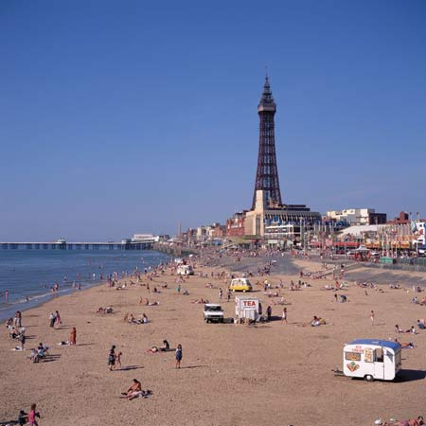Much of the post-World War II expansion of international tourism was based on beach holidays, which have a long history. In their modern, commercial form, beach holidays are an English invention of the 18th century, based on the medical adaptation of popular sea-bathing traditions. They built upon the positive artistic and cultural associations of coastal scenery for societies in the West, appealing to the informality and habits and customs of maritime society. Later beach holiday destinations incorporated the sociability and entertainment regimes of established spa resorts, sometimes including gambling casinos. Beach holidays built on widespread older uses of the beach for health, enjoyment, and religious rites, but it was the British who formalized and commercialized them. From the late 18th and early 19th centuries, beach resorts spread successively across Europe and the Mediterranean and into the United States, then took root in the European-settled colonies and republics of Oceania, South Africa, and Latin America and eventually reached Asia.
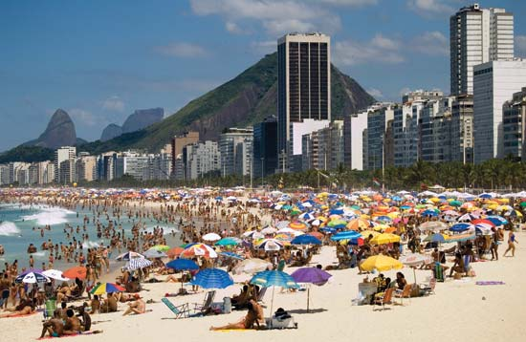Beach holiday environments, regulations, practices, and fashions mutated across cultures as sunshine and relaxation displaced therapy and convention. Coastal resorts became sites of conflict over access and use as well as over concepts of decency and excess. Beaches could be, in acceptably exciting ways, liminal frontier zones where the usual conventions could be suspended. (Not just in Rio de Janeiro have beaches become carnivalesque spaces where the world has been temporarily turned upside down.) Coastal resorts could also be dangerous and challenging. They could become arenas for class conflict, starting with the working-class presence at the 19th-century British seaside, where it took time for day-trippers from industrial towns to learn to moderate noisy, boisterous behaviour and abandon nude bathing. Beaches were also a prime location for working out economic, ethnic, “racial,” or religious tensions, such as in Mexico, where government-sponsored beach resort developments from the 1970s displaced existing farming communities. In South Africa the apartheid regime segregated the beaches, and in the Islamic world locals sustained their own bathing traditions away from the tourist beaches.
The beach is only the most conspicuous of many distinctive settings to attract a tourist presence and generate a tourism industry, but its history illustrates many general points about tradition, diffusion, mutation, and conflict. Tourism has also made use of history, as historic sites attract cultural tourists and collectors of iconic images. Indigenous peoples can sometimes profit from the marketability of their customs, and even the industrial archaeology of tourism itself is becoming good business, with historically significant hotels, transport systems, and even amusement park rides becoming popular destinations. Heritage and authenticity are among the many challenging and compromised attributes that tourism uses to market the intangible wares that it appropriates. The global footprint of tourism—its economic, environmental, demographic, and cultural significance—was already huge at the beginning of the 20th century and continues to grow exponentially. As the body of literature examining this important industry continues to expand, historical perspectives will develop further.
John K. Walton
- share Share
Share:
- mail_outline Email
- print Print
- bookmark Cite
- Last Updated 3-20-2015

chat Feedback
Corrections? Updates? Help us improve this article! Contact our editors with your Feedback.

