Exercise 3
Topic: Conversion between systems of systems (CRS), simple operations on layers, performing calculations in the attribute table, data visualization.

Today's task concerns the development of a road density map in the Lublin province (where the basic unit will be municipalities). Please load three layers, the bottom of which are the 1992 Reference System (municipality_1992.shp; province_1992.shp) and the third in WGS84 (roads_wgs84.shp). Due to the large amount of data, we will first start by isolating the roads that interest us in terms of location.
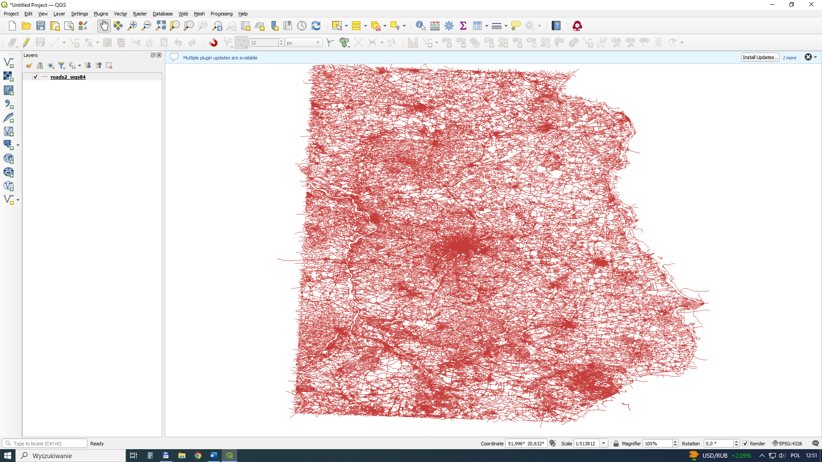

Save the file to a new layer changing the coordinate reference system (CRS) (roads2_1992.shp).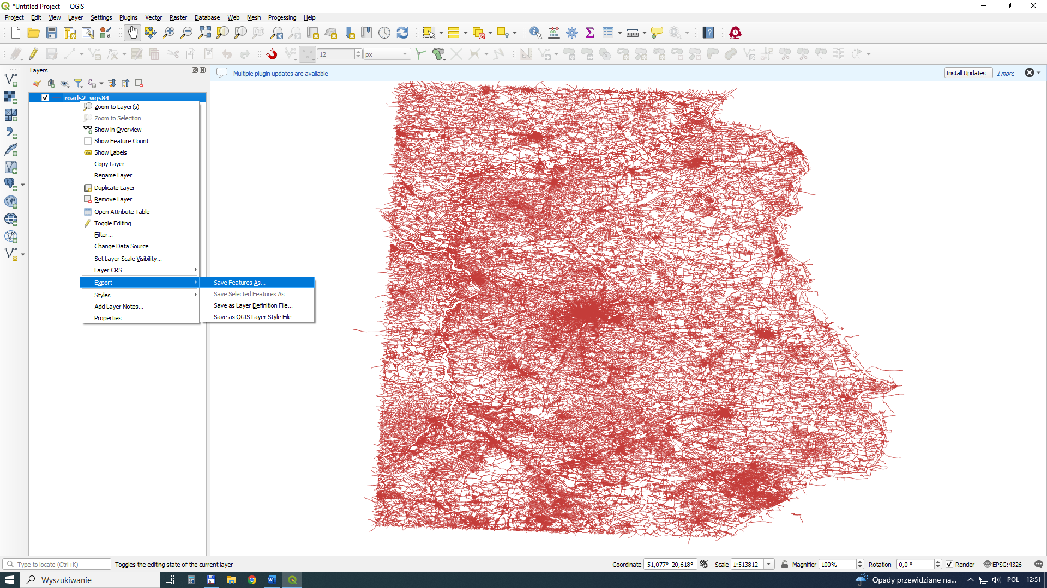

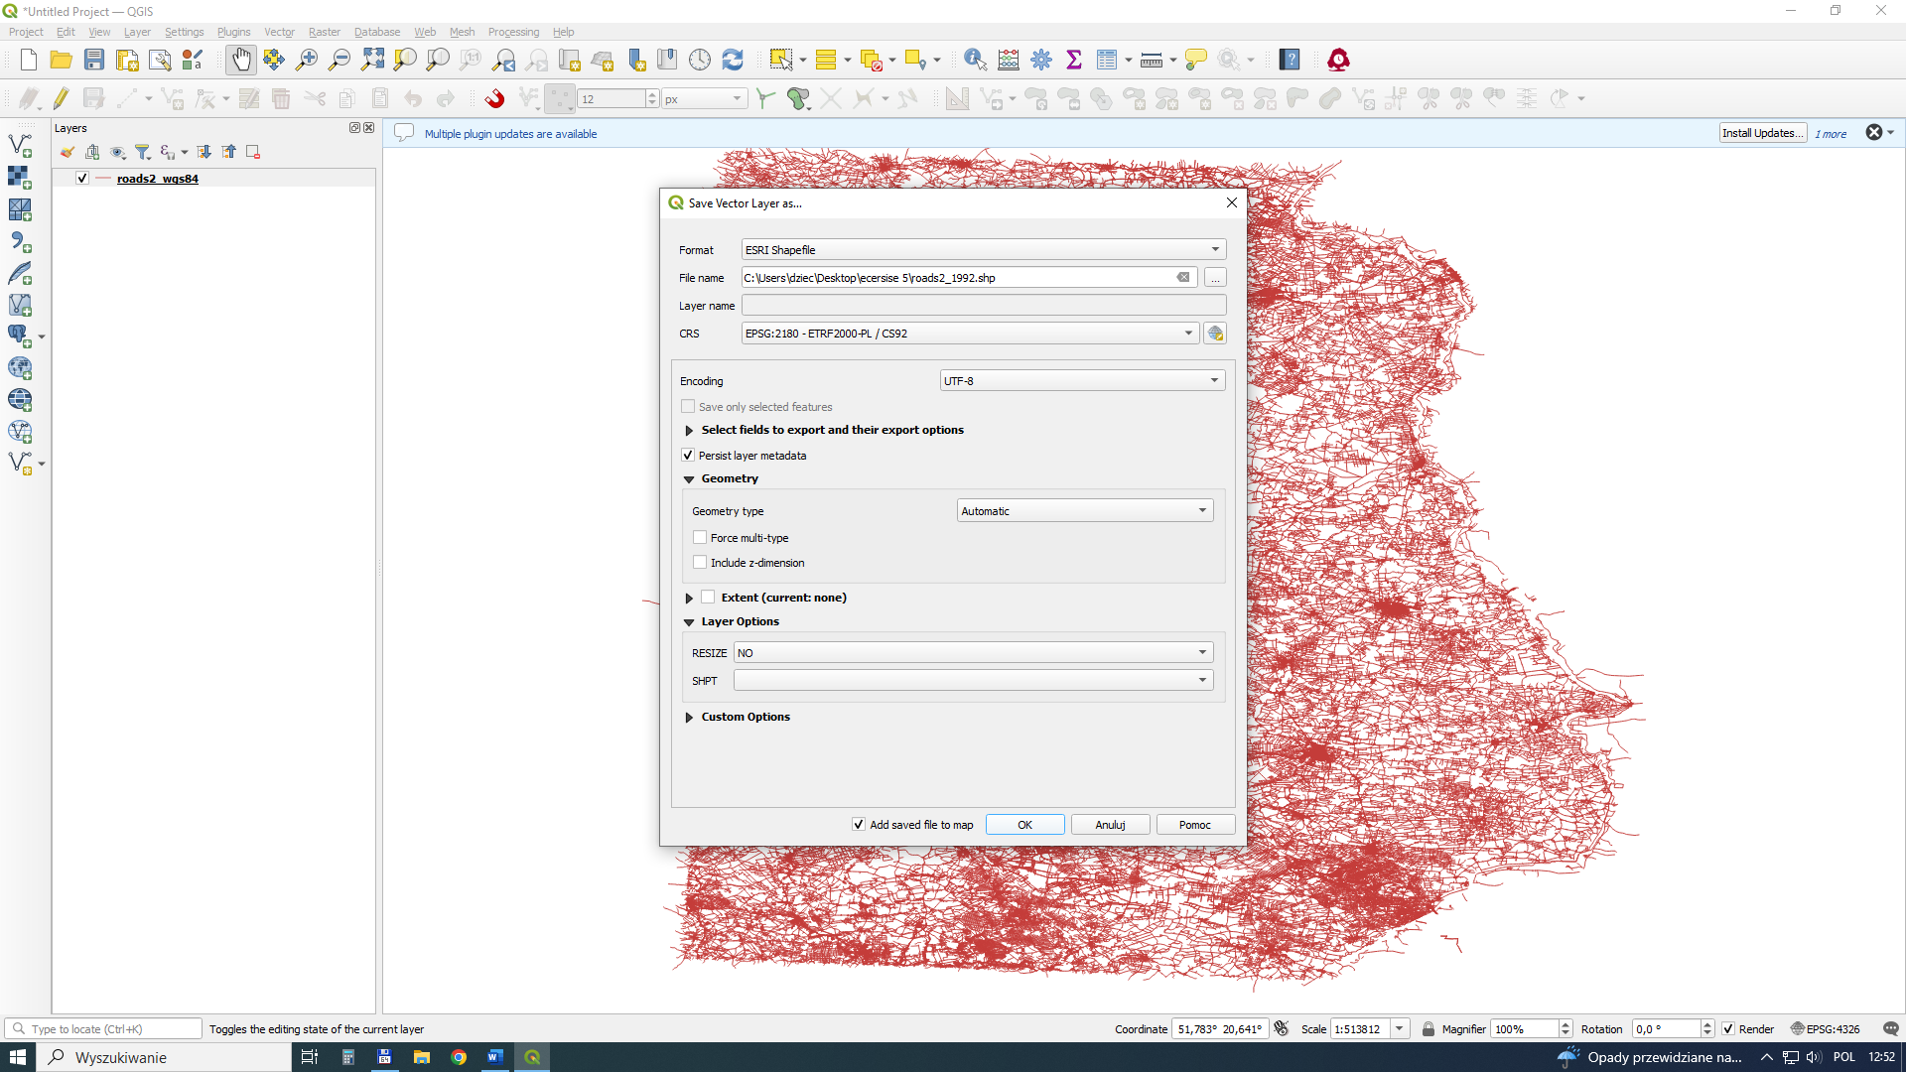

As a result of changing the layout, the road network geometry is changed. Remember to change the CRS in the way the data is displayed (bottom left corner). Now all data is in the 1992 system.
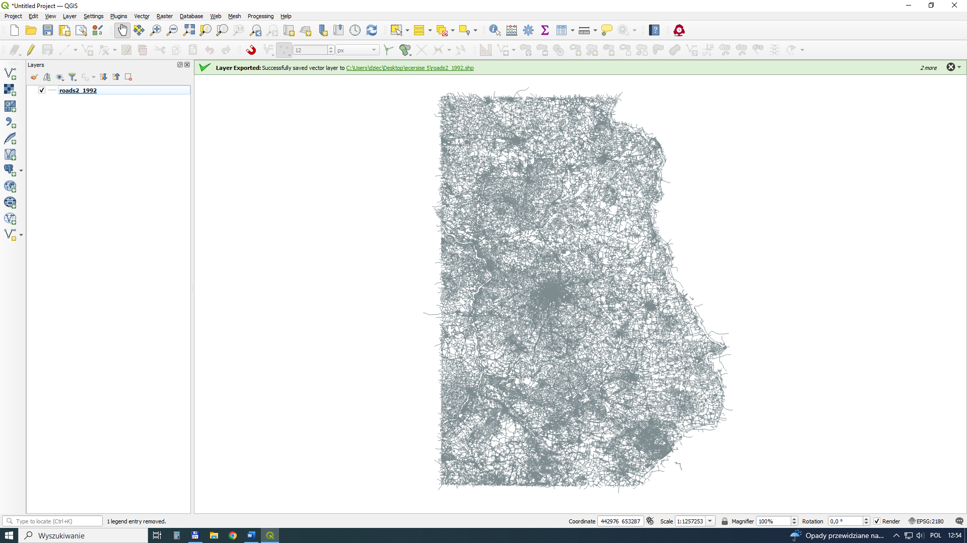
Load data on the Lublin province (province_1992.shp). With its help, we will mark roads located within the province border.
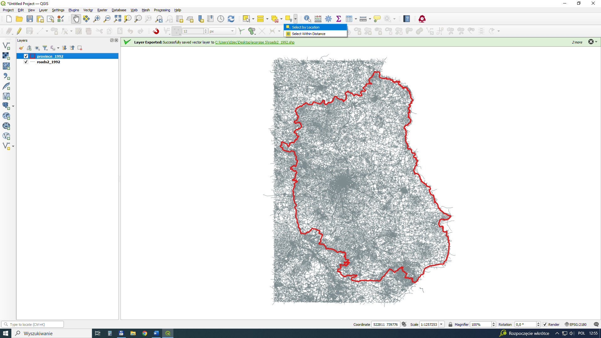

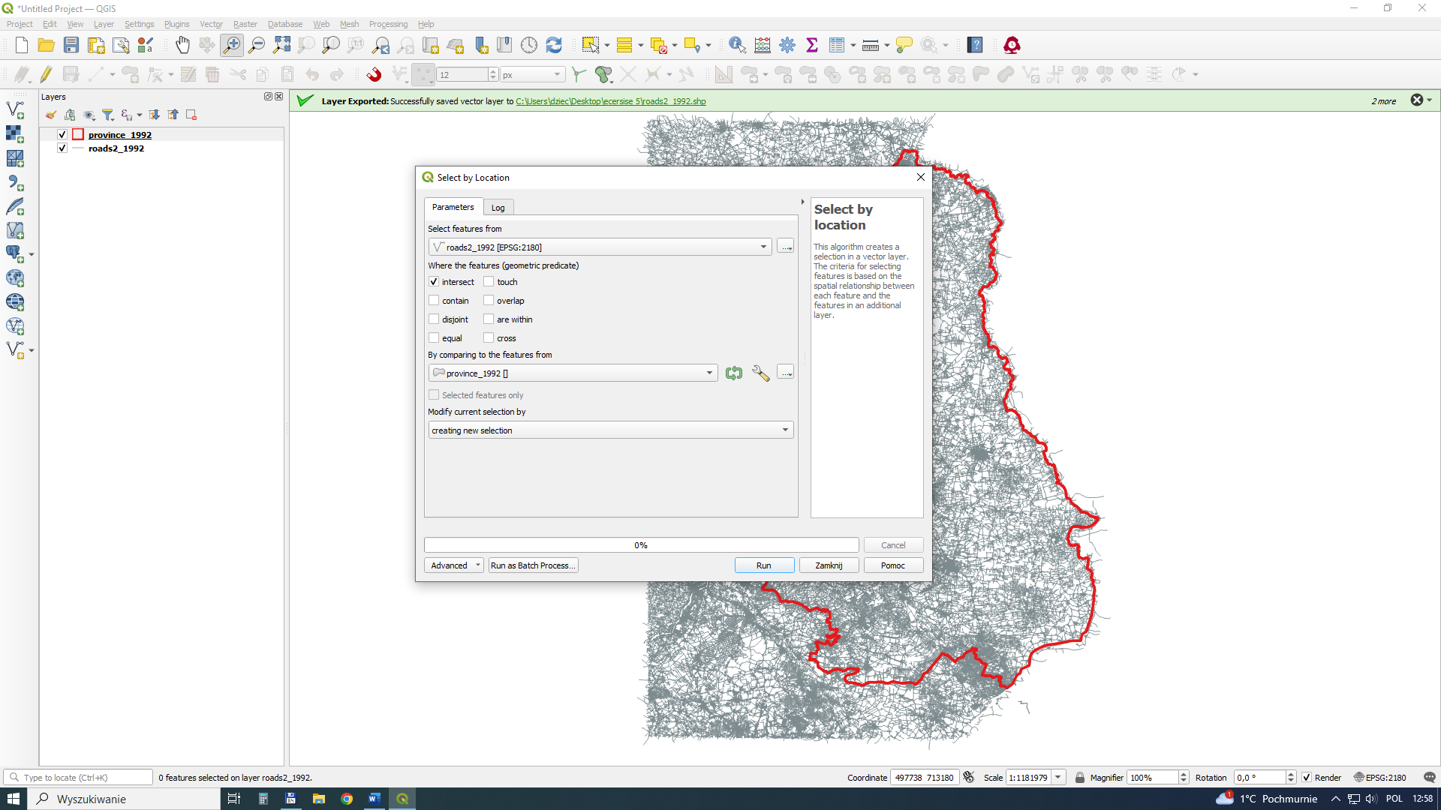

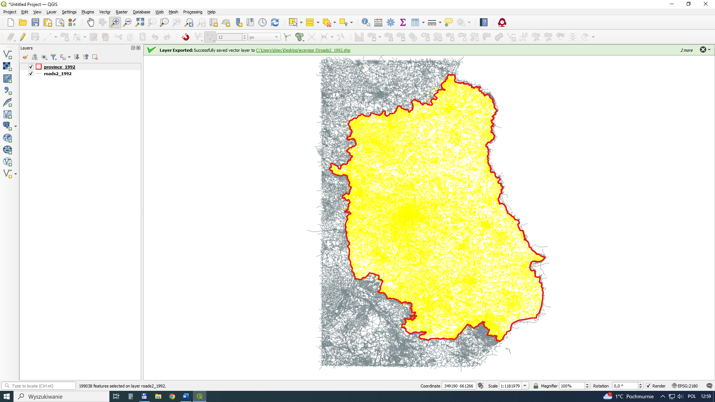

Some of the roads extend beyond the province borders and need to be clip (Vector- Geoprocessing-Clip)to the province border. The selection effect is visible in yellow.
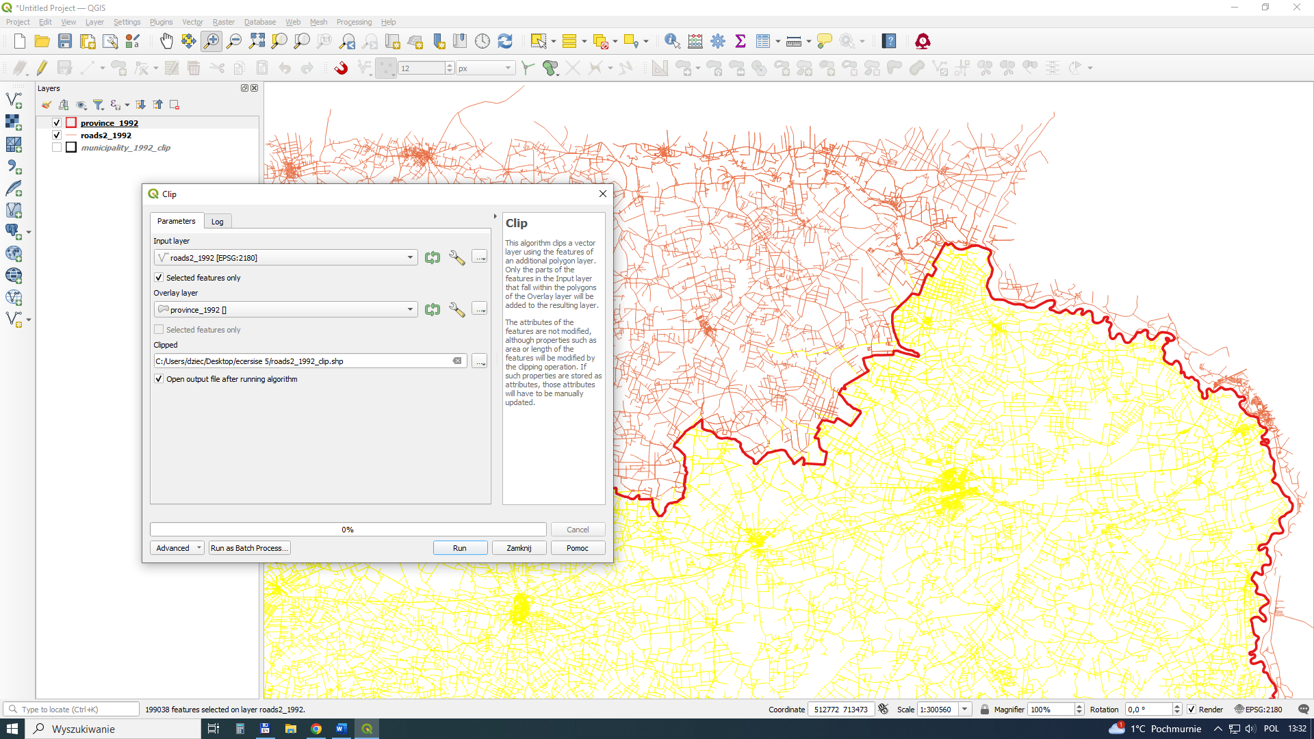

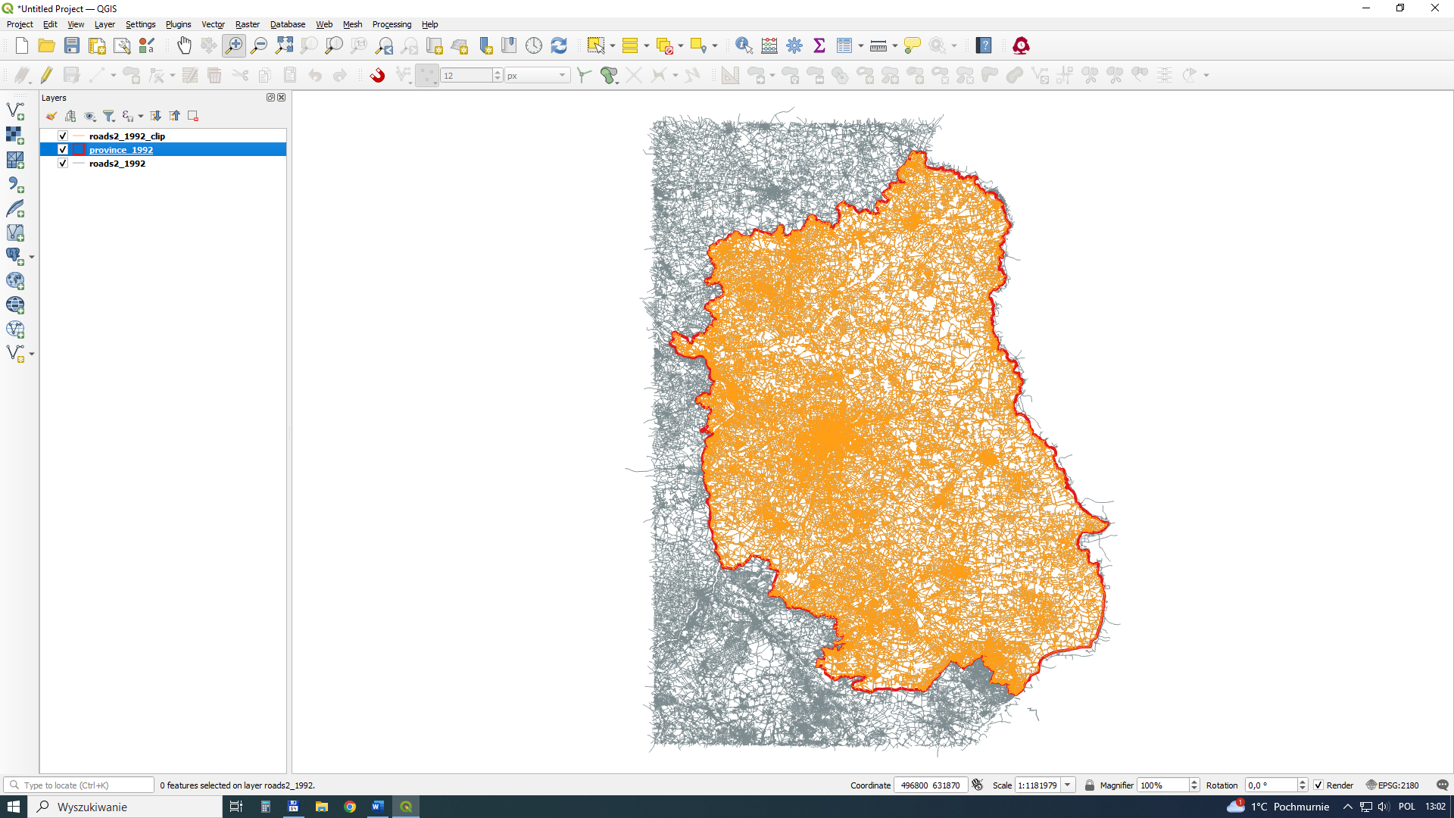

As in the case of roads, mark the communes located within the province borders.
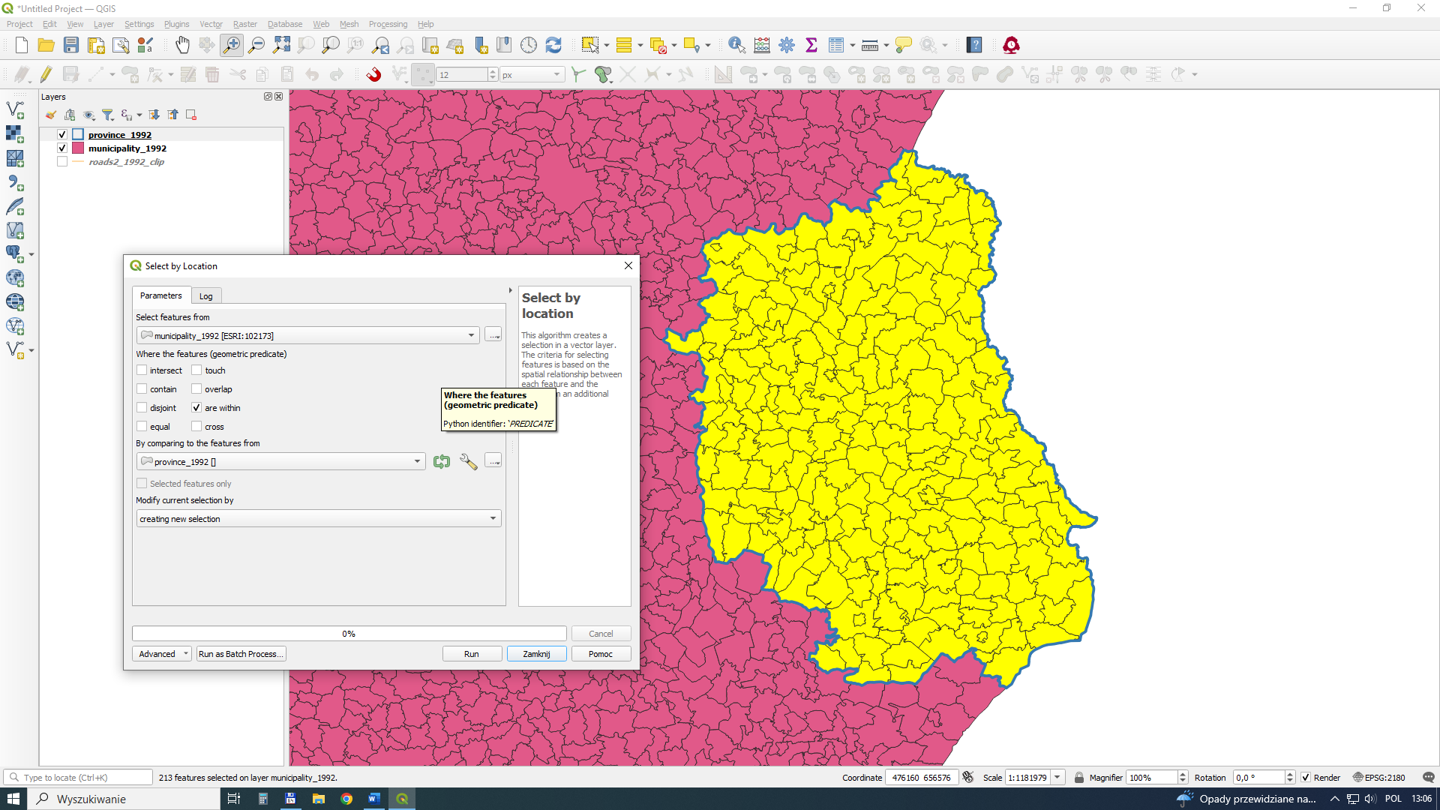
Save selected polygons to a new layer (municipality 1992 clip.shp).
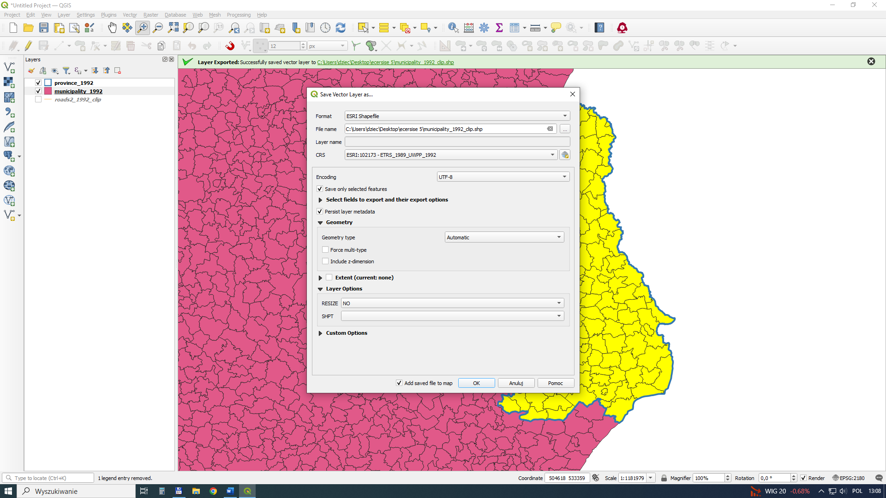

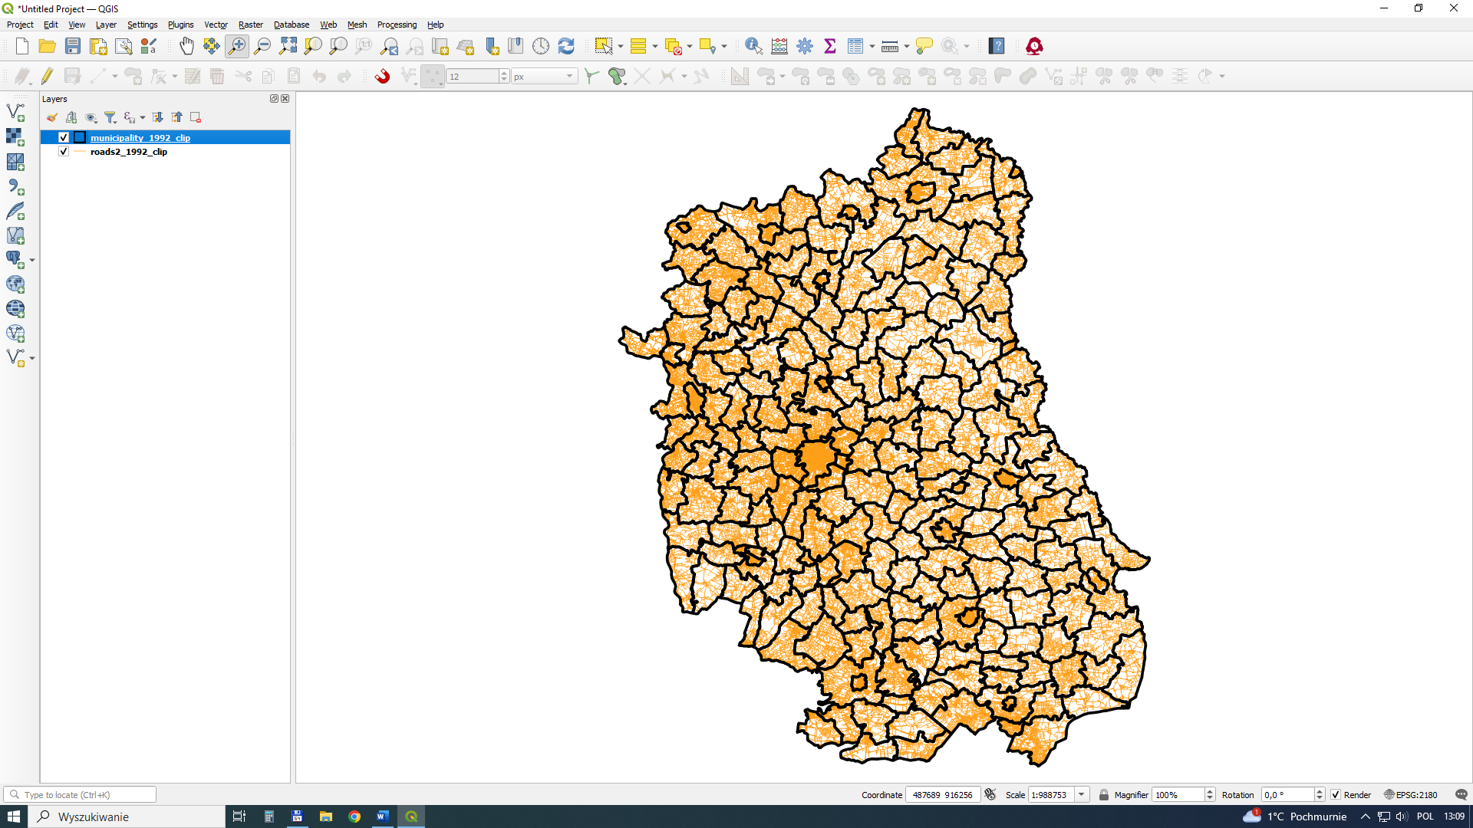
Use the tool to count the length of roads (Sum line length) in a given administrative unit. In the case of a geographical system (e.g. WGS84) it is not possible to calculate the length of the line, because the basic unit is a degree per unit of length (e.g. meter).
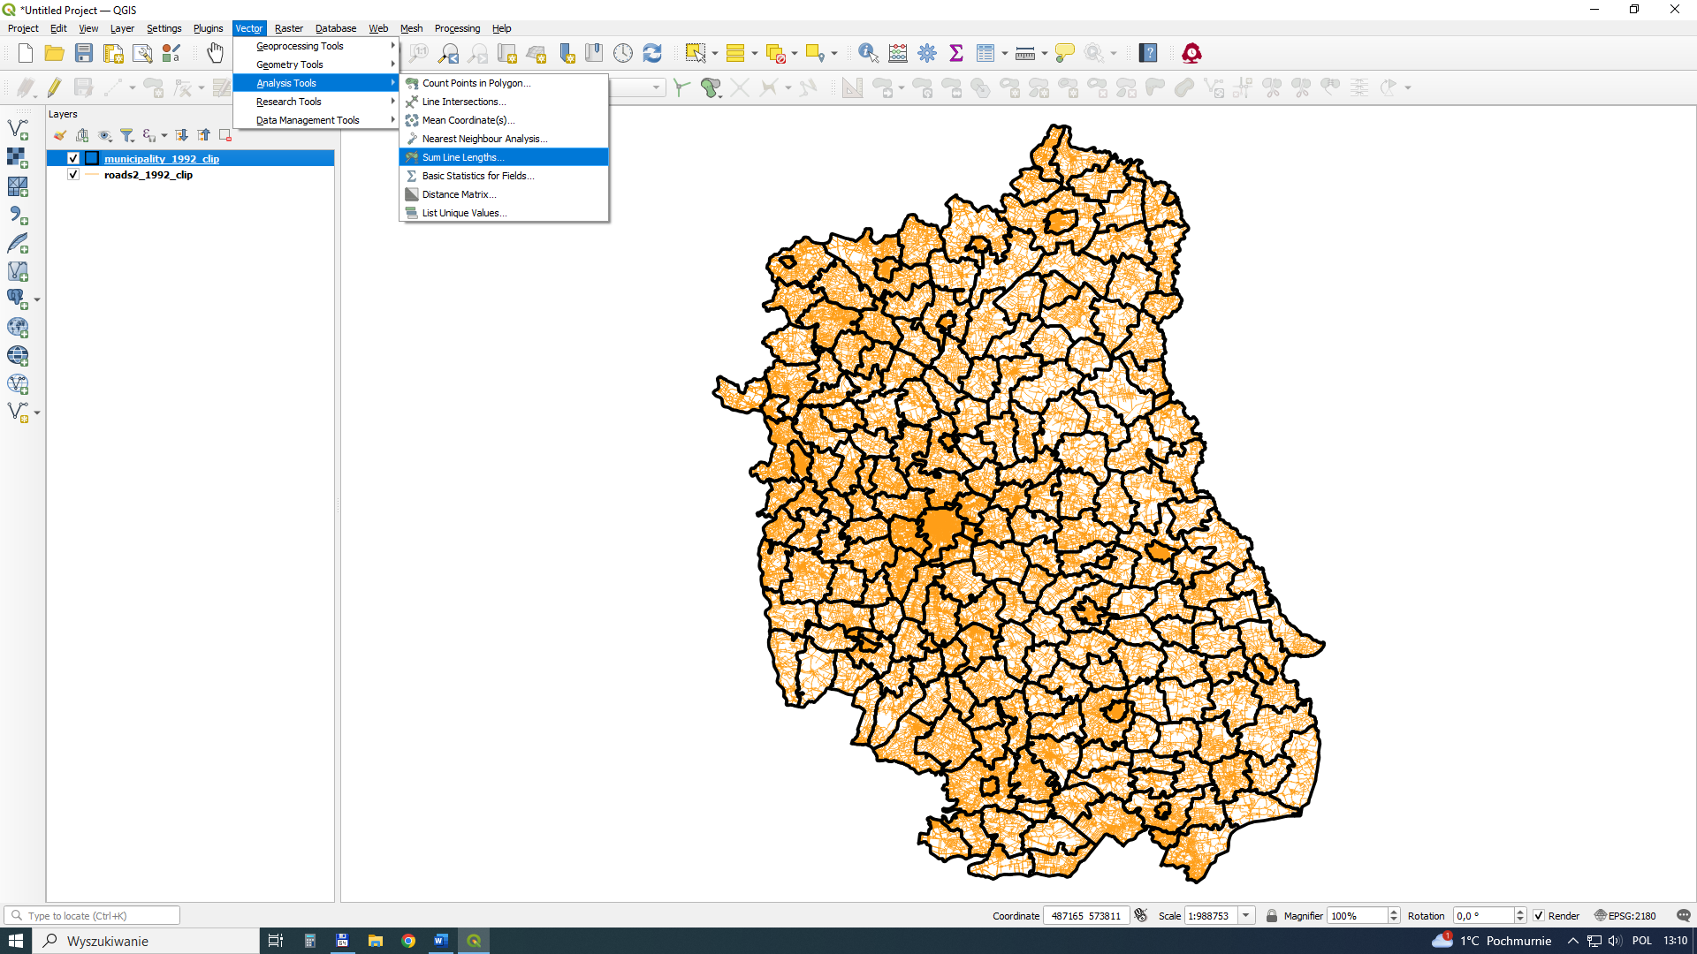

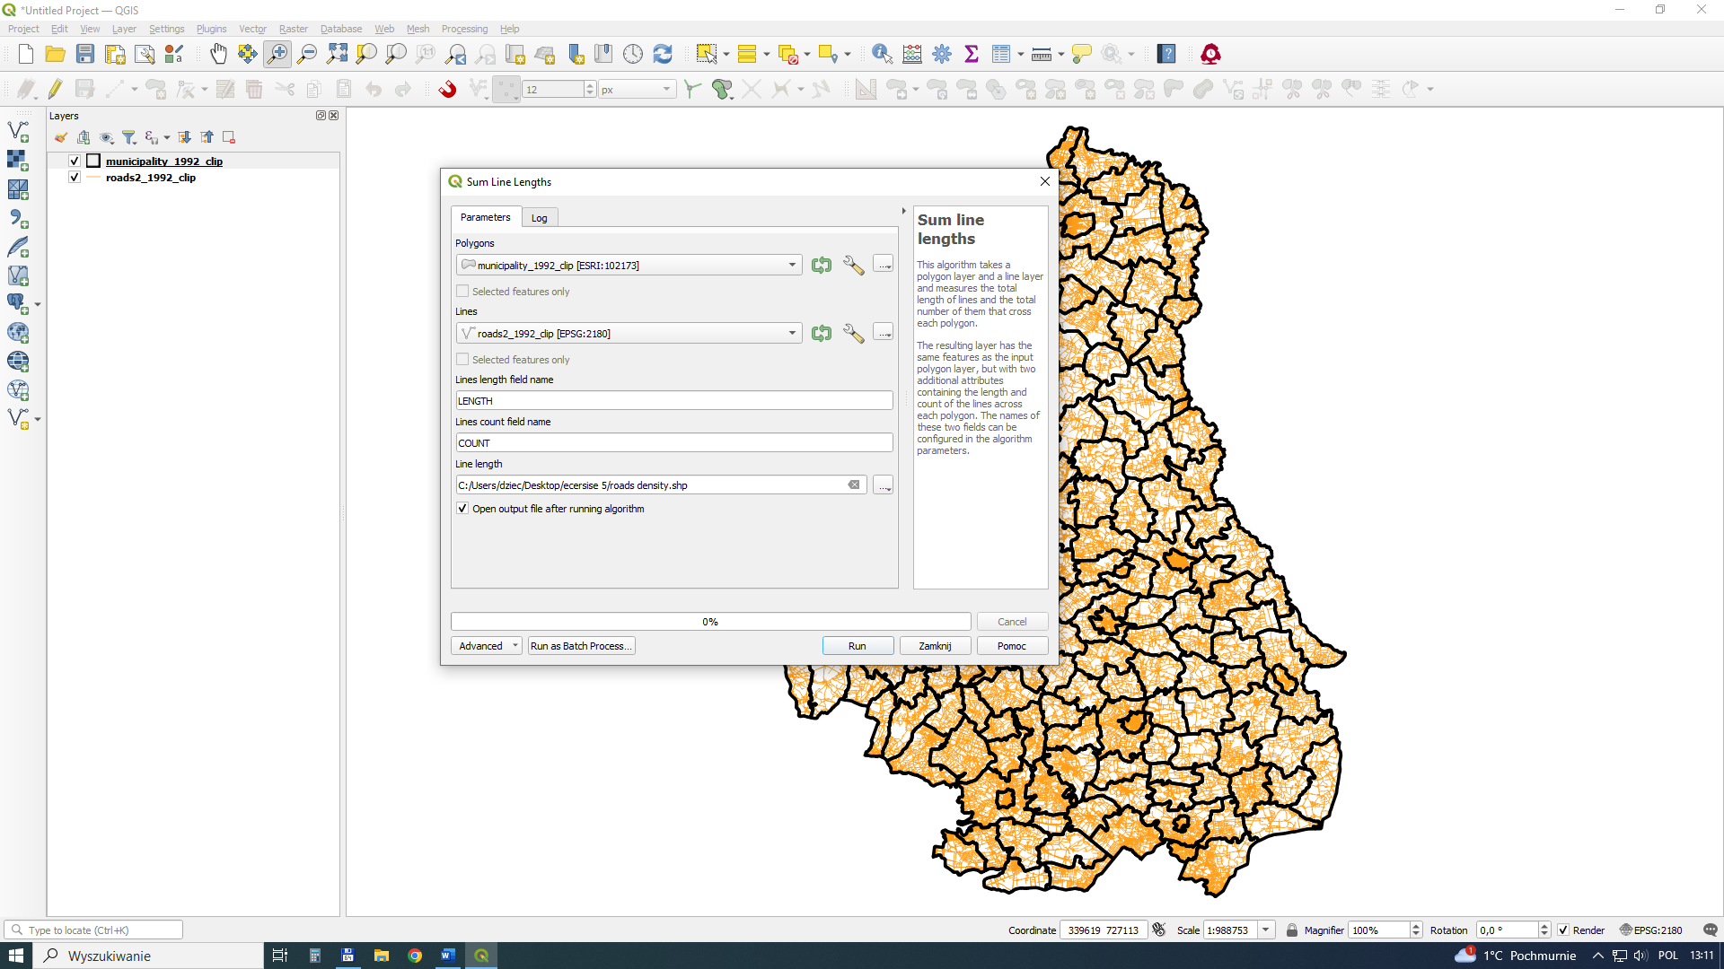
The result of this action is a new layer, with new data in the attribute table. The total length of roads is expressed in meters.
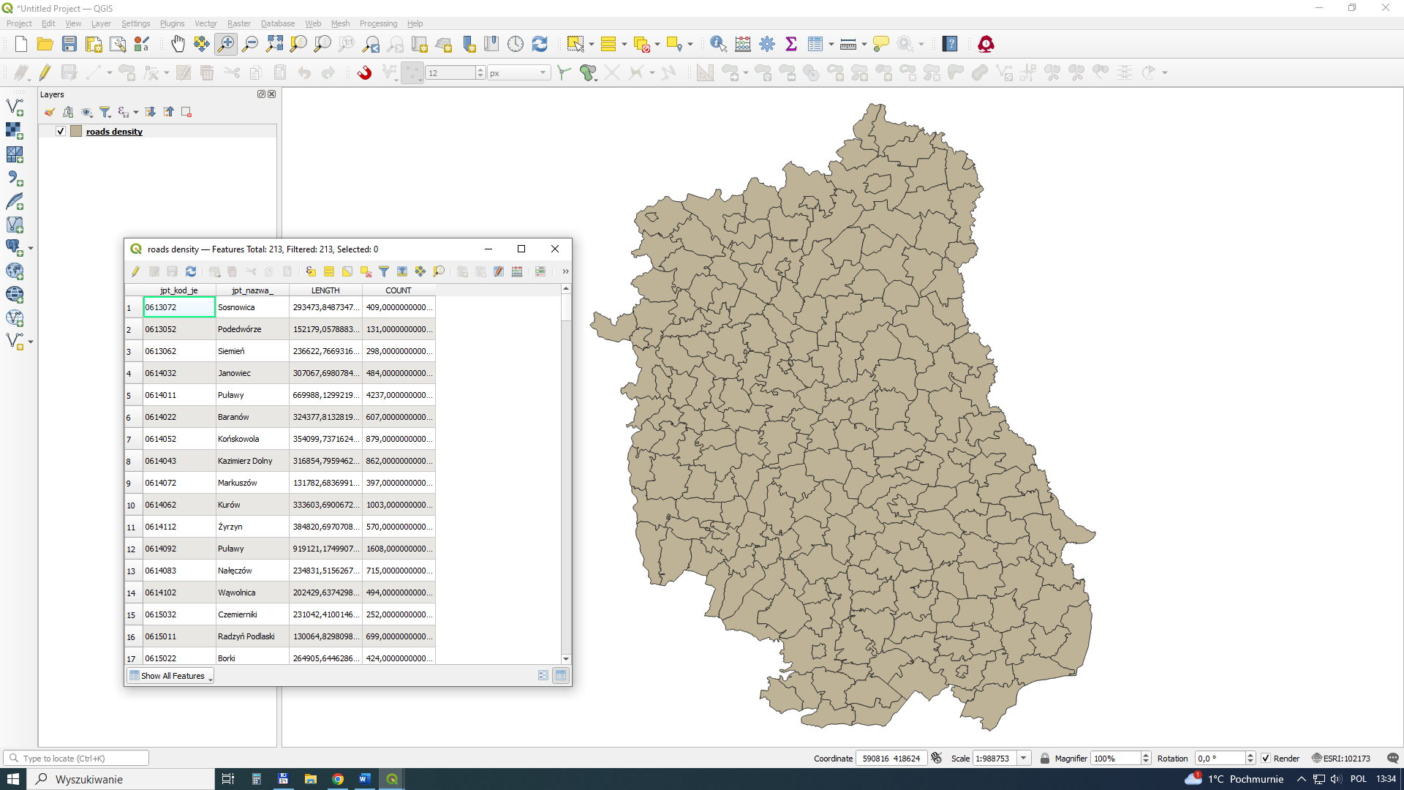

The effect of our activities is to be a map of road density relative to the area of a given commune (km/km²). To calculate it, we lack the area of the commune. You need to create a new column in the attribute table and calculate the area.
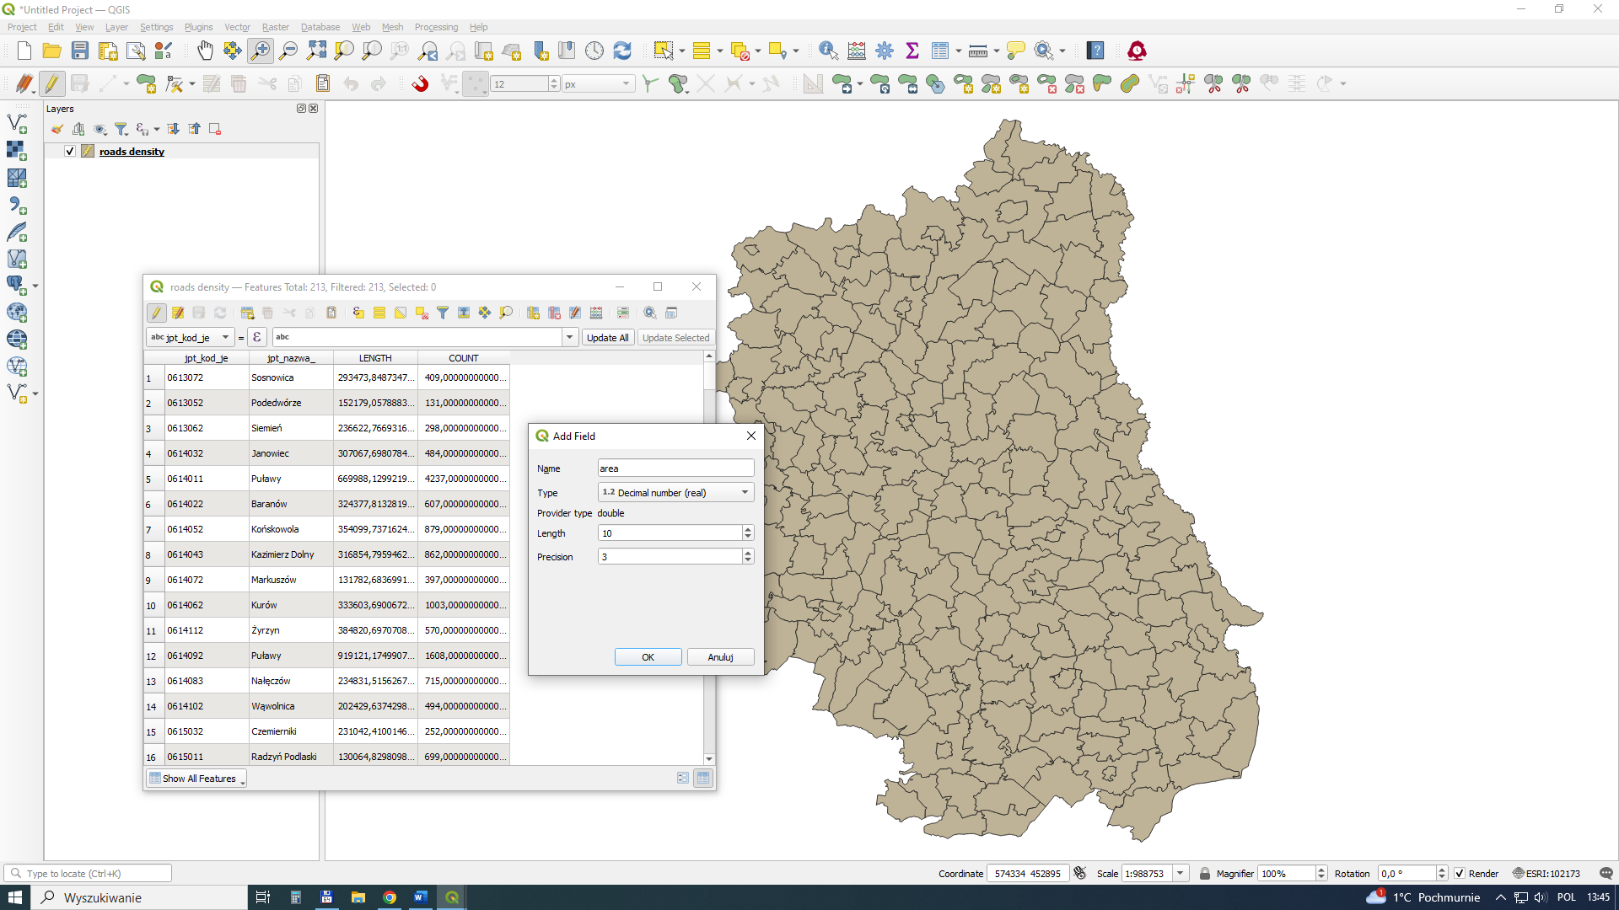

You need to create a new column in the attribute table and calculate the area. And then automatically calculate the area.
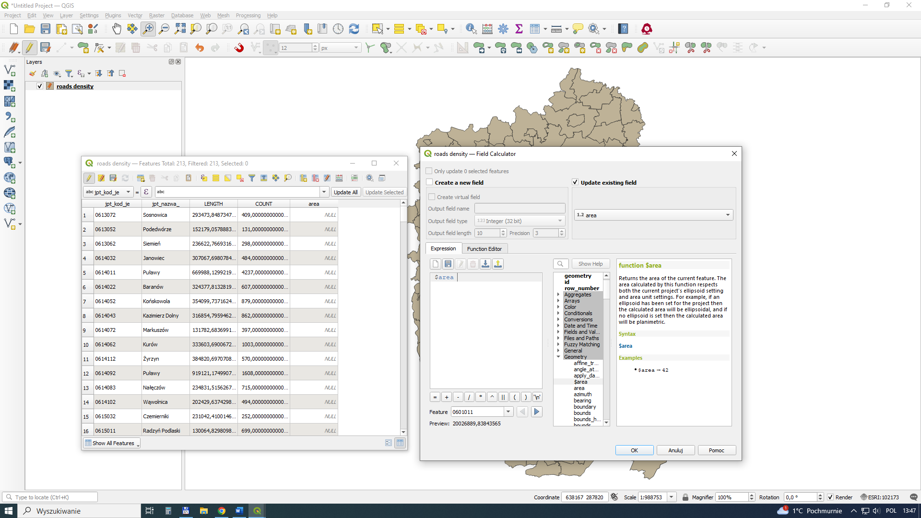

The calculations were made in square meters, due to the basic unit of the 1992 system. Remember to convert this unit to km² in the next steps.
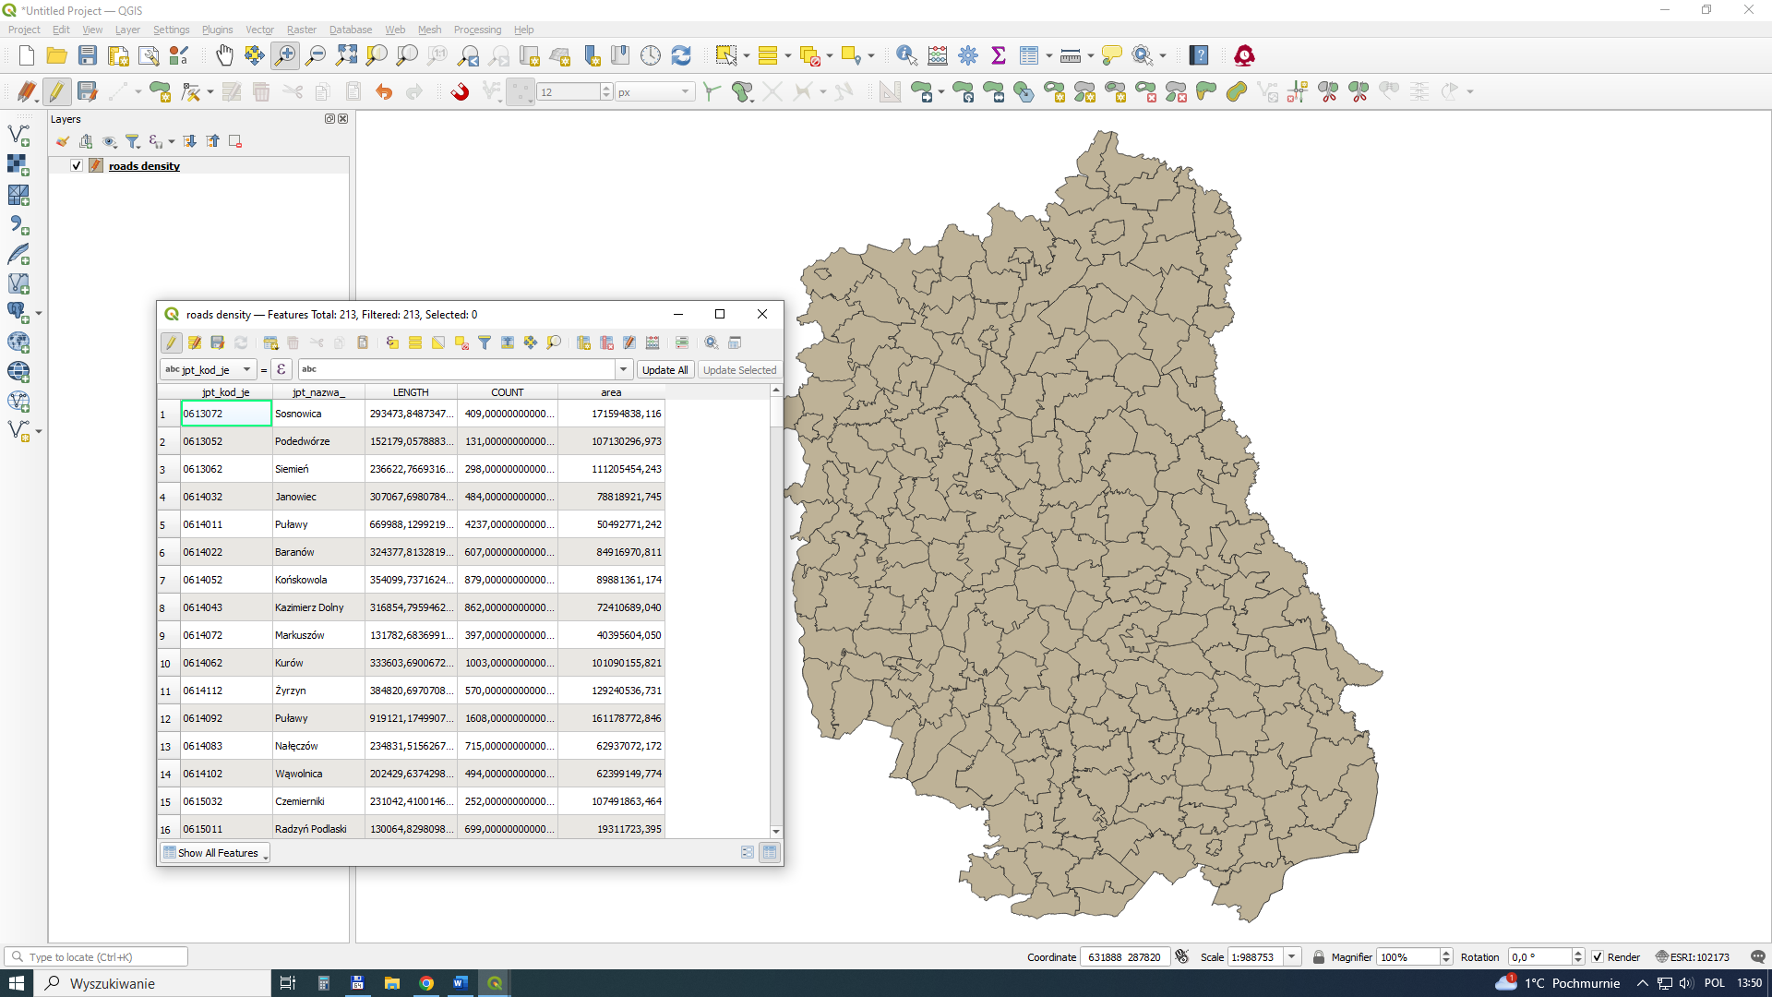
Create a new column for final calculations (density) ("LENGTH" /1000)/("area" /(1000*1000))
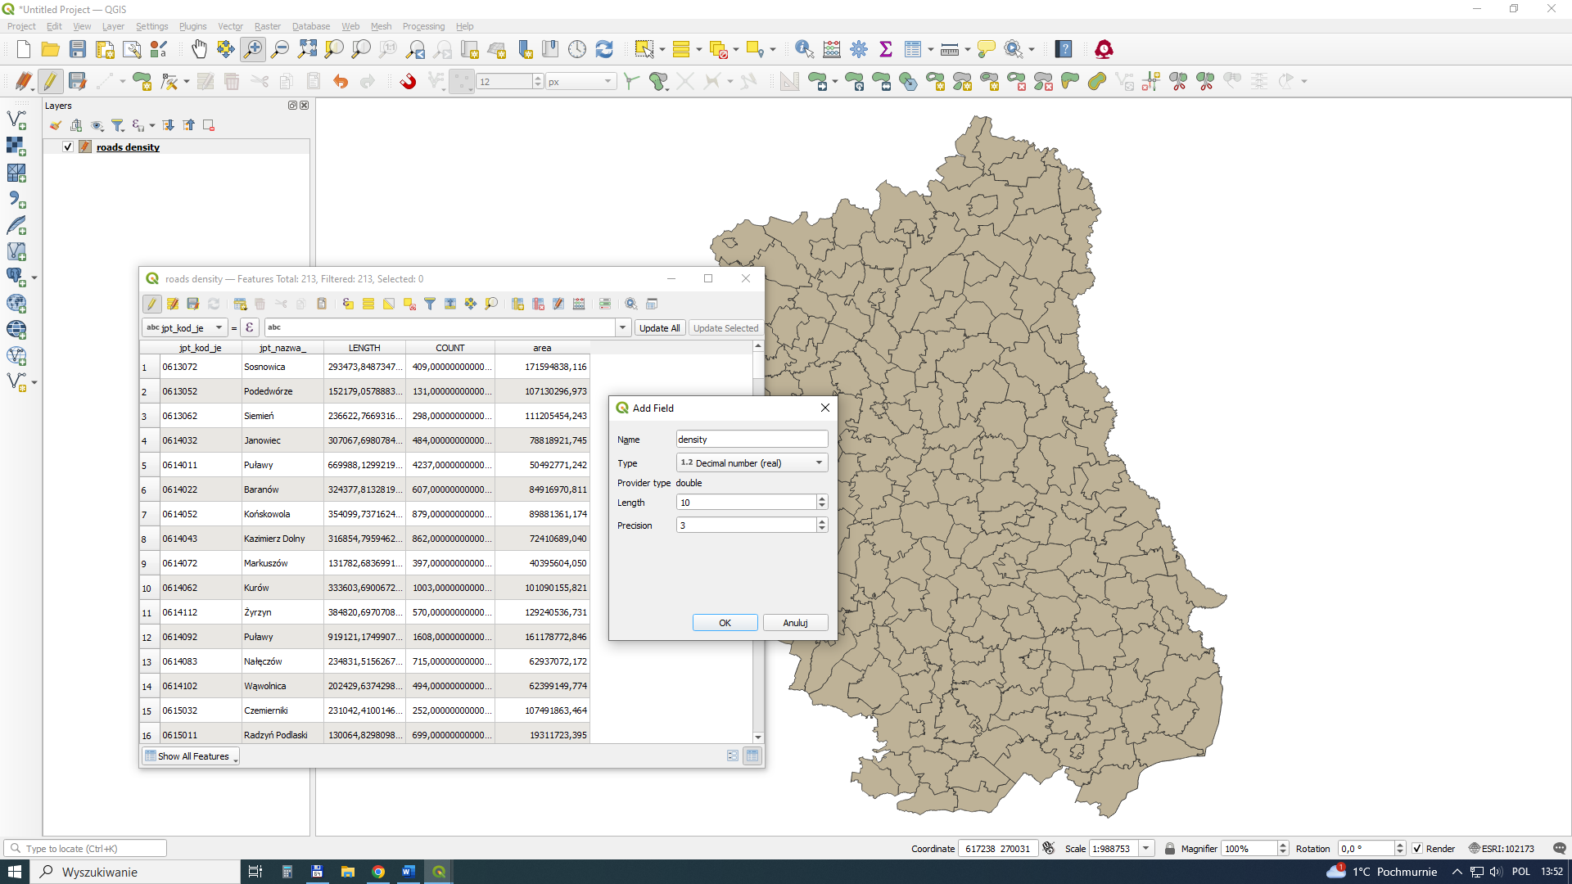

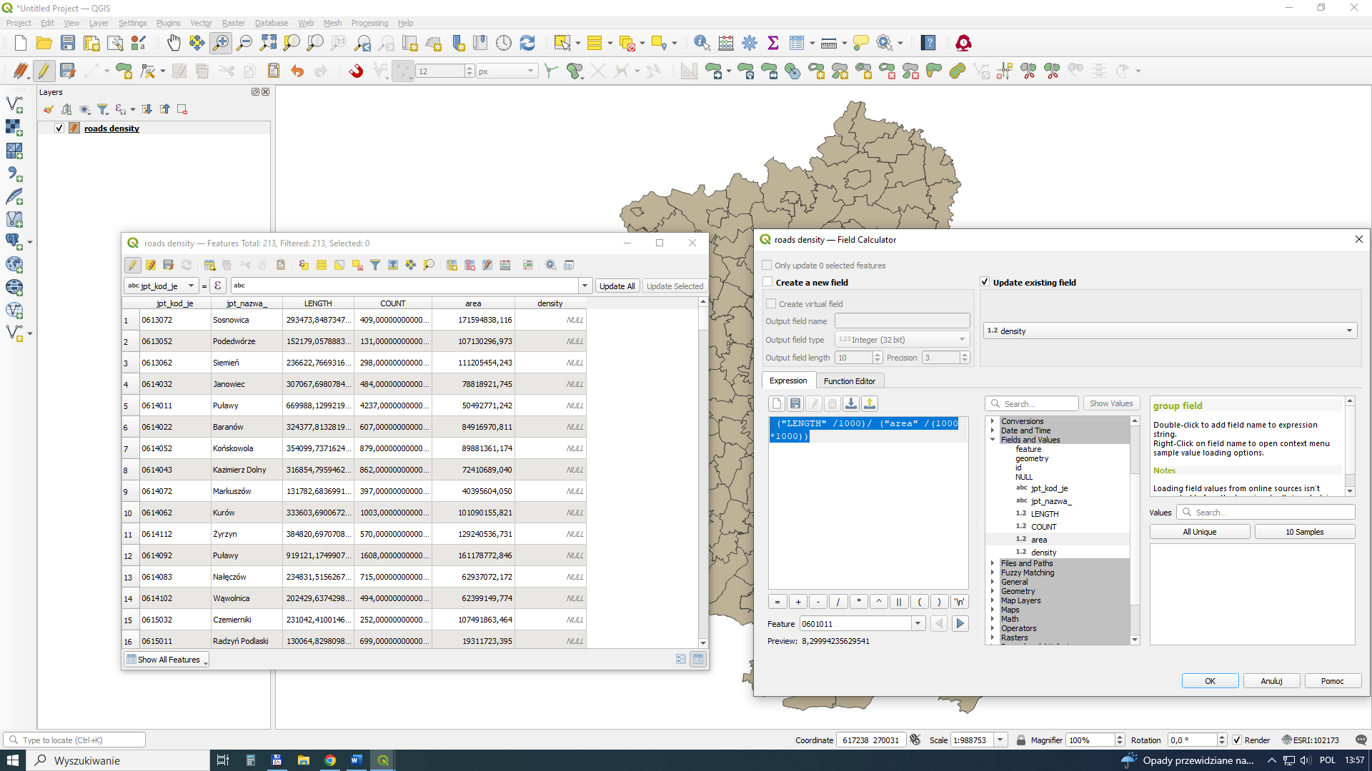

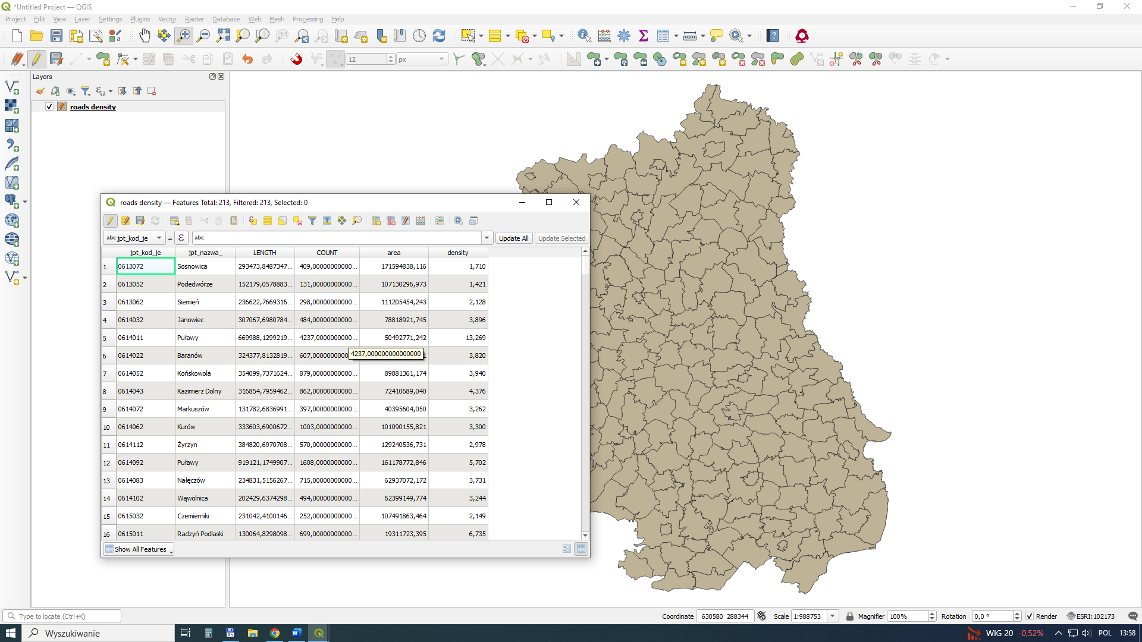

It presents several results using different methods of determining interval classes.
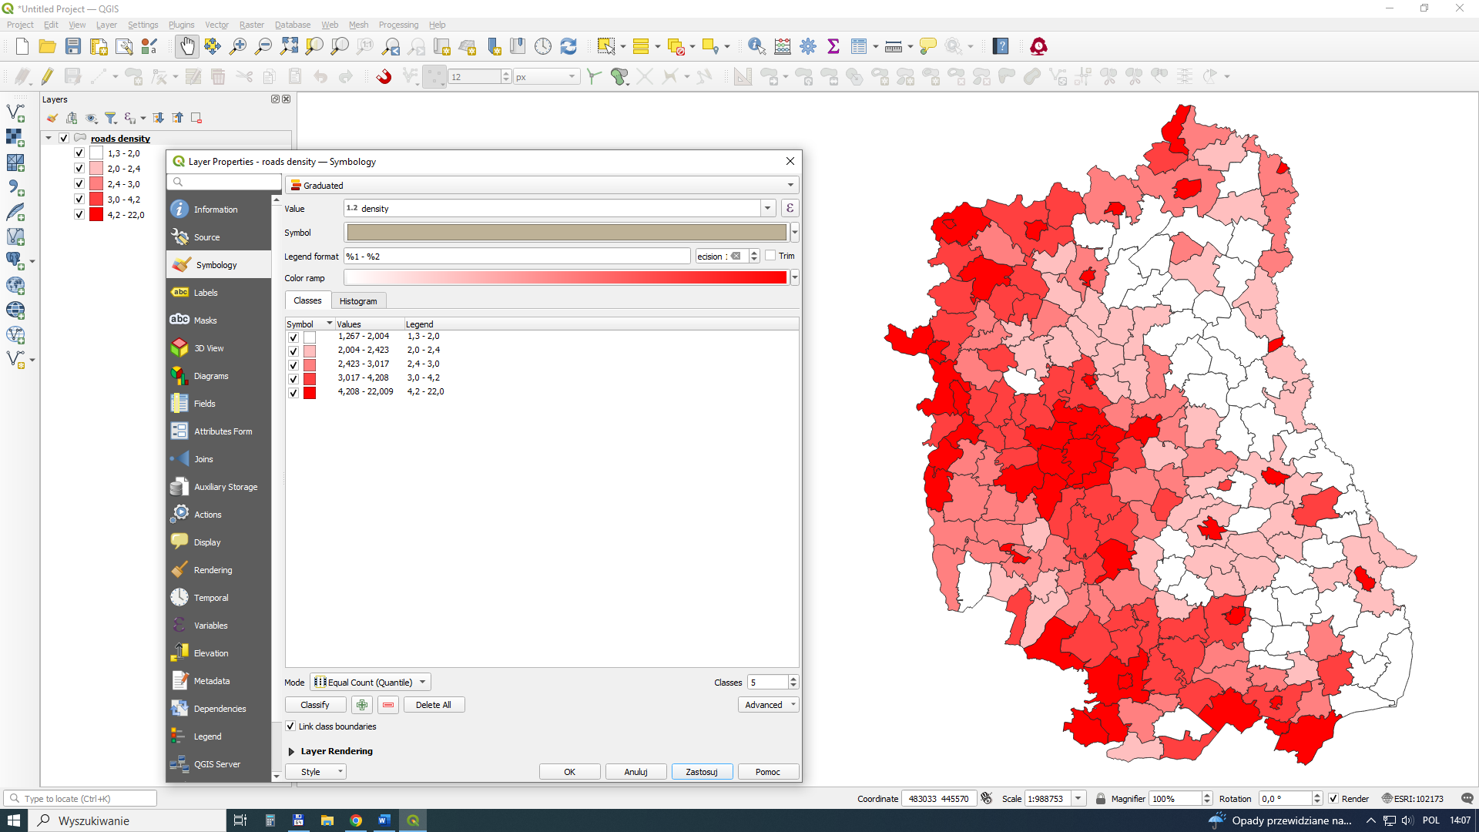
Equal Count
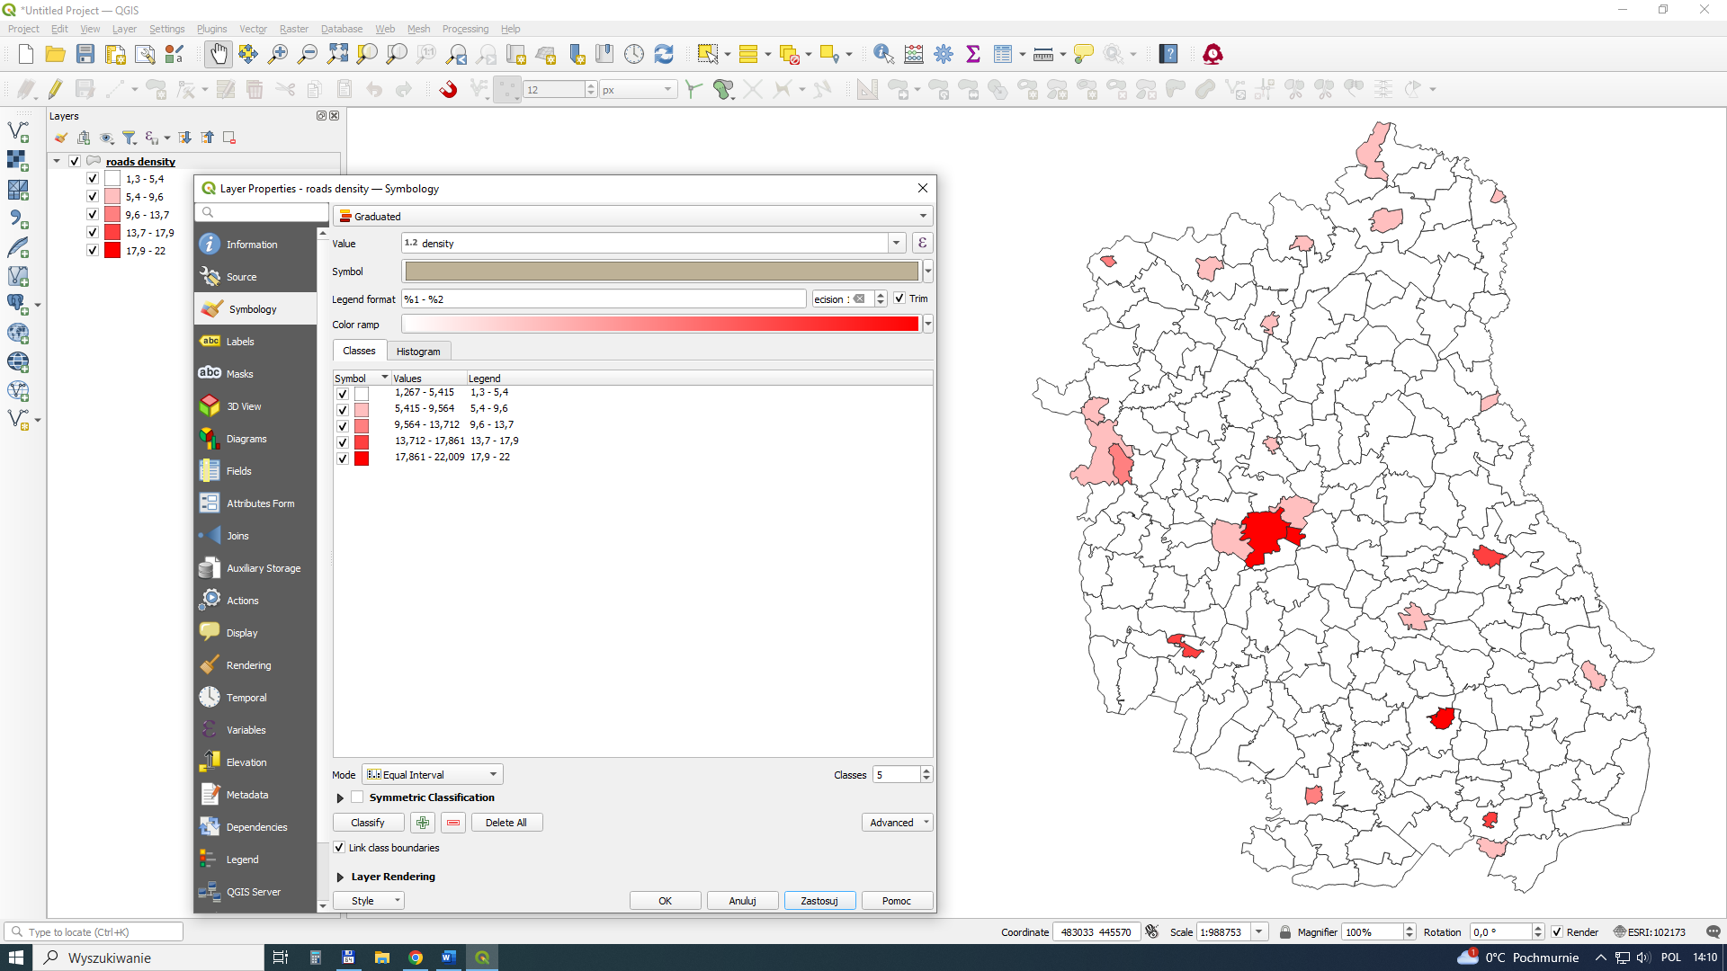
Equal Interval

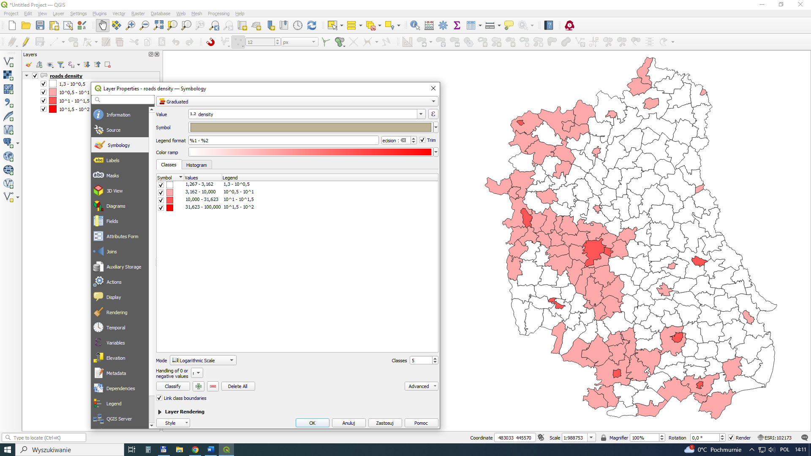
Logarithmic Scale
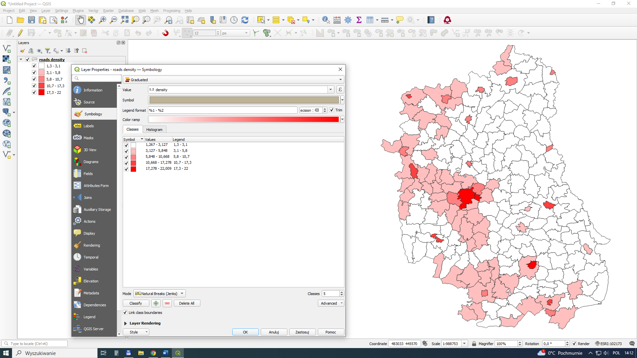
Natural Breaks

Homework: Develop three maps for road density (km/km2) up to 50 km/h, from 50.1 km/h to 90 km/h, and above 90.1 km/h. The prompt is the appropriate query.

